**FULL STACK WEB DEVLOPMENT LAB**

**MINI PROJECT - Front End Development**

**TITLE:** Atlas travel ticketing

**Team Members**

V L Harisudhan (1934010)

K P Nithish Kumaar (1934026)

**HTML, CSS, JAVASCRIPT CODE:**

1. **Home page - Flight ticket booking page**

**HTML Code:**

<!DOCTYPE html>

<html>

<head>

<meta charset="utf-8">

<title>ATLAS: Explore Outdoors</title>

<link rel="stylesheet" type="text/css" href="style.css">

<link href="https://fonts.googleapis.com/css2?family=Rampart+One&display=swap" rel="stylesheet">

<link href="https://fonts.googleapis.com/css2?family=Zen+Antique&display=swap" rel="stylesheet">

<link href="https://fonts.googleapis.com/css2?family=Oswald:wght@600&display=swap" rel="stylesheet">

<!-- Navigation bar-->

<header>

<div class="header">

<img style="height:45px ;" src="globe.png" alt = "logo">

<h1 style="margin-top: 5px;">atlas</h1>

<img style="height: 25px; margin-left: 300px; margin-top: -55px;" src="plane.png">

<a class="four" href="Home_page.html" style="margin-left: 340px; margin-top: -55px;" >Flights</a>

<img style="height: 25px; margin-left: 440px; margin-top: -55px;"src="train.png">

<a class="four" href="train.html" style="margin-left: 480px; margin-top: -55px;" >Trains</a>

<img style="height: 25px; margin-left: 570px; margin-top: -55px;"src="bus.png">

<a class="four" href="bus.html" style="margin-left: 610px; margin-top: -55px;" >Bus</a>

<img style="height: 25px; margin-left: 1305px; margin-top: -55px;"src="user.png">

<a class="four" href="login_signup.html" style="margin-left: 1345px; margin-top: -55px;" >Login/signup</a>

<img style="height: 25px; margin-left: 1105px; margin-top: -55px;"src="telephone-call.png">

<a class="four" href="customer_care.html" style="margin-left: 1145px; margin-top: -55px;" >Customer care</a>

</div>

</header>

</head>

<body>

<div id="cf">

<img class="bottom" src="https://wallup.net/wp-content/uploads/2016/04/06/359511-India-Taj_Mahal-Asian_architecture-love-landscape-water-reflection-sunset.jpg" />

<img class="top" src="https://www.gujarattourism.com/content/dam/gujrattourism/images/religious-sites/akshardham-temple/Akshardham-Temple-Banner.jpg" />

<img class="bottom" src="https://upload.wikimedia.org/wikipedia/commons/1/1f/Thiruvalluvar_Statue_At_Kanyakumari_%28197523127%29.jpeg">

<img class = "bottom" src="https://pix10.agoda.net/geo/city/3667/1_3667_02.jpg?s=1920x822">

<img class = "bottom" src="https://img.theculturetrip.com/wp-content/uploads/2018/02/8517681001_bebaf23525_k.jpg">

<div class="text-block">

<form style="display: inline-block;float: right;">

<label><b>From</b></label>

<select id="from", name="from">

<option value="chennai">MAA - Chennai, India</option>

<option value="bangalore">BLR - Bangaluru, India</option>

<option value="Hyderabad">HYD - Hyderabad, India</option>

<option value="Mumbai">BOM - Mumbai, India</option>

<option value="Delhi">DEL - New Delhi, India</option>

</select>&emsp;

<label><b>To</b></label>

<select id="from", name="from">

<option value="chennai">MAA - Chennai, India</option>

<option value="bangalore">BLR - Bangaluru, India</option>

<option value="Hyderabad">HYD - Hyderabad, India</option>

<option value="Mumbai">BOM - Mumbai, India</option>

<option value="Delhi">DEL - New Delhi, India</option>

</select>&emsp;

<label><b>Departure</b></label>

<input type="date" name="departure" value="date">&emsp;

<label><b>Return</b></label>

<input type="date" name="return" value="date">&emsp;

<label><b>Class</b></label>

<select id="class", name="class">

<option value="economy">Economy</option>

<option value="business">Bussiness</option>

<option value="premium_economy">Premium economy</option>

</select>&emsp;

<!-- <input type="submit" class="button button3"> -->

<a class="button button3" href="fight_selection_page.html">Submit</a>

</form>

</div>

</div>

<section class="offerimage">

<img style="margin-top: 600px; height: 200px; padding-bottom: 11px; margin-left: 15px" src="https://gos3.ibcdn.com/img-1613303670.jpg">

<img style="margin-top: 600px; height: 200px; padding-bottom: 11px; margin-left: 22.5px" src="https://hotdealszone.com/wp-content/uploads/2019/05/Amazon-flight-booking-offer-1024x278.jpg">

</section>

<section class="offer">

<p id = "offertitle", style="margin-top: 852px; text-align: center; margin-bottom: 6px; padding-top: 10px; padding-bottom: 10px; font-size: 30px;"><b><i>SPECIAL OFFER</i></b></p>

<div>

<div class="polaroid rotate_right">

<img src="https://media-cdn.tripadvisor.com/media/photo-s/0d/de/f0/eb/backwater-tourism.jpg" alt="Kochi, Kerela" width="284" height="213">

<p class="caption"><b><a href="">Kochi, Kerela, India</a></b></p>

</div>

<div class="polaroid rotate_left">

<img src="https://sites.google.com/site/chikucabserviceindia/_/rsrc/1597911260621/explore-the-beauty-of-mumbai-with-taxi-services/bandra%20worli%20sea%20link%20mumbai.jpg" alt="Worli island, Maharastra" width="284" height="213">

<p class="caption"><b><a href="">Worli island, Maharastra India</a></b></p>

</div>

<div class="polaroid rotate_right">

<img src="https://img.traveltriangle.com/blog/wp-content/uploads/2018/02/assam-tourist-places.jpg" alt="Assam, India" width="284" height="213">

<p class="caption"><b><a href="">Assam, India</a></b></p>

</div>

<div class="polaroid rotate_left">

<img src="https://c.ndtvimg.com/2020-08/gom2ebv_mahabalipuram_295x200_20_August_20.jpg" alt="Mahabalipuram, Chennai" width="284" height="213">

<p class="caption"><b><a href="">Mahabalipuram, Chennai, India</a></b></p>

</div>

<div class="polaroid rotate_left">

<img src="https://img.traveltriangle.com/blog/wp-content/uploads/2019/02/Hawa-Mahal_24th-oct.jpg" alt="Hawa Mahal, Jaipur" width="284" height="213">

<p class="caption"><b><a href="">Hawa Mahal, Jaipur, India</a></b></p>

</div>

<div class="polaroid rotate_right">

<img src="https://www.tusktravel.com/blog/wp-content/uploads/2019/10/Gadi-Sagar-Lake-Jaisalmer.jpg" alt="Jaisalmer, Rajasthan" width="284" height="213">

<p class="caption"><b><a href="">Jaisalmer, Rajasthan, India</a></b></p>

</div>

<div class="polaroid rotate_left">

<img src="https://www.rentmytent.in/images/blogs/D1DEF380/709E7270.webp" alt="Coorg, Karnataka" width="284" height="213">

<p class="caption"><b><a href="">Coorg, Karnataka, India</a></b></p>

</div>

<div class="polaroid rotate_right">

<img src="https://www.swantour.com/blogs/wp-content/uploads/2018/02/Golconda-Fort-Hyderabad.jpg" alt="Golconda fort, Hyderabad" width="284" height="213">

<p class="caption"><b><a href="">Golconda fort, Hyderabad, India</a></b></p>

</div>

</div>

</div>

</section>

<!-- Footer -->

<footer class="footer">

<br>

<div style="margin-bottom: -40px; margin-left: 30px;">

<img style="width: 20px;" src="facebook.png"> &emsp; <img style="width: 20px;" src="twitter.png"> &emsp; <img style="width: 20px;" src="instagram.png">

</div>

<div class="footer_ref">

<p><a class="one" href="">About us</a> &emsp; <a class="one" href="">Investors relations</a> &emsp; <a class="one" href="">CSR</a> &emsp; <a class="one" href="">Mobile</a> &emsp; <a class="one" href="">Privacy</a> &emsp; <a class="one" href="">Terms of use</a> &emsp; <a class="one" href="">Careers</a> &emsp; <a class="one" href="">Customer service</a> <br><br> </p>

</div><br><br><br><hr>

<p style="margin-left:470px; padding-bottom: 20px; color: white">&copy; 2021 ATLAS Technologies Pvt Ltd. India. All trademarks of their respective owners.</p>

</footer>

</body>

</html>

**Common CSS style for all pages.**

.header img{

float: left;

margin-left: 30px;

position: relative;

display: inline-block;

cursor: pointer;

margin-right: 10px;

}

.header a{

float: left;

margin-left: 10px;

position: relative;

display: inline-block;

font-size: 17px;

text-decoration: none;

font-family: 'Zen Antique', serif;

}

a.four:link {color:#ff0000;}

a.four:visited {color:black;}

a.four:hover {font-family:monospace;}

a.four:hover {color:red;}

.header h1{

font-family: 'Rampart One', cursive;

}

#cf {

position: relative;

}

#cf img {

animation-name: cf3FadeInOut;

animation-timing-function: ease-in-out;

/* if you only want to cycle a finite amount of times,

simply change 'infinite' with # of iterations you need */

animation-iteration-count: infinite;

animation-duration: 50s;

animation-direction: alternate; /* not strictly necessary */

position:absolute;

height: 600px;

width: 100%;

}

#cf img:nth-of-type(1) {

animation-delay: 40s;

}

#cf img:nth-of-type(2) {

animation-delay: 30s;

}

#cf img:nth-of-type(3) {

animation-delay: 20s;

}

#cf img:nth-of-type(4) {

animation-delay: 10s;

}

#cf img:nth-of-type(5) {

animation-delay: 0s;

}

@keyframes cf3FadeInOut {

/* distributing times evenly */

0% {

opacity: 1;

}

25% {

opacity: 0;

}

75% {

opacity: 0;

}

100% {

opacity: 1;

}

}

#cf{

margin-top: -15px;

}

.text-block {

position: absolute;

bottom: -400px;

right: 100px;

background-color: black;

color: white;

padding-left: 20px;

padding-right: 20px;

padding-top: 20px;

padding-bottom: 20px;

opacity: 0.7;

font-size: 20px;

}

.button {

background-color: #4CAF50; /* Green */

border: none;

color: white;

padding: 5px 16px;

text-align: center;

text-decoration: none;

display: inline-block;

font-size: 16px;

margin: 4px 2px;

transition-duration: 0.4s;

cursor: pointer;

}

.button3 {

background-color: white;

color: black;

border: 2px solid #f44336;

}

.button3:hover {

background-color: #f44336;

color: white;

}

.offerimage{

background-image: linear-gradient(to right, #000066, #ccffff , #000066);

display: inline-block;

float: right;

padding-right: 15px;

}

.offer img{

padding: 10px;

box-shadow: 8px 10px 10px #888888;

}

#offertitle{

font-family: 'Oswald', sans-serif;

background-color: #B0C4DE;

background-image: linear-gradient(to right, #000066, #ccffff , #000066);

}

div.rotate_right {

float: left;

-ms-transform: rotate(7deg); /* IE 9 */

-webkit-transform: rotate(7deg); /* Safari */

transform: rotate(7deg);

margin-top: 40px;

margin-left: 55px;

}

div.rotate_left {

float: left;

-ms-transform: rotate(-8deg); /* IE 9 */

-webkit-transform: rotate(-8deg); /* Safari */

transform: rotate(-8deg);

margin-left: 55px;

margin-top: 40px;

}

.caption{

text-align: center;

}

.footer{

background-image: linear-gradient(#ccffff , #000066);

margin-top: 680px;

}

.footer_ref{

display: inline-block;

float: right;

margin-right: 395px;

}

a.one:link {color:#ff0000;}

a.one:visited {color:#00008B;}

a.one:hover {color: white}

.footer img{

cursor: pointer;

}

.footer hr{

width: 910px;

}

.card {

/* Add shadows to create the "card" effect */

box-shadow: 0 4px 8px 0 rgba(0,0,0,0.3);

transition: 0.3s;

}

/* On mouse-over, add a deeper shadow */

.card:hover {

box-shadow: 5px 8px 16px 5px rgba(0,0,0,0.5);

}

/* Add some padding inside the card container */

.container {

padding: 2px 16px;

padding-left: 200px;

padding-right: 200px;

background-image: url('https://encrypted-tbn0.gstatic.com/images?q=tbn:ANd9GcR2gOp_o0HxgwsnD2iyj3XXC2eFq5Q8KyYD6A&usqp=CAU');

background-repeat: no-repeat;

background-size: cover;

}

a.five:link {color:#ff0000;text-decoration:none;}

a.five:visited {color:#0000ff;text-decoration:none;}

a.five:hover {text-decoration:underline;}

**Home Page:**

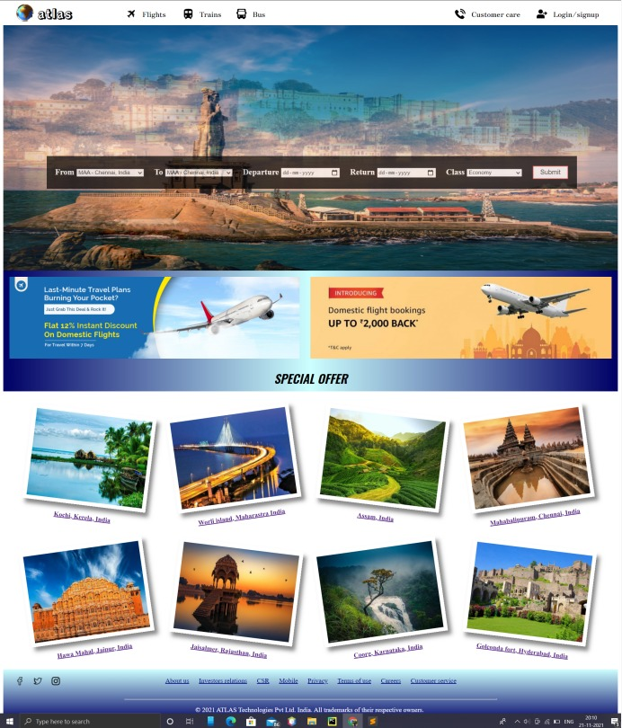

1. **Train ticket booking page:**

**HTML:**

<!DOCTYPE html>

<html>

<head>

<meta charset="utf-8">

<title>Book train tickets</title>

<link rel="stylesheet" type="text/css" href="style.css">

<link href="https://fonts.googleapis.com/css2?family=Rampart+One&display=swap" rel="stylesheet">

<link href="https://fonts.googleapis.com/css2?family=Zen+Antique&display=swap" rel="stylesheet">

<link href="https://fonts.googleapis.com/css2?family=Oswald:wght@600&display=swap" rel="stylesheet">

<header>

<div class="header">

<img style="height:45px ;" src="globe.png" alt = "logo">

<h1 style="margin-top: 5px;">atlas</h1>

<img style="height: 25px; margin-left: 300px; margin-top: -55px;" src="plane.png">

<a class="four" href="Home_page.html" style="margin-left: 340px; margin-top: -55px;" >Flights</a>

<img style="height: 25px; margin-left: 440px; margin-top: -55px;"src="train.png">

<a class="four" href="train.html" style="margin-left: 480px; margin-top: -55px;" >Trains</a>

<img style="height: 25px; margin-left: 570px; margin-top: -55px;"src="bus.png">

<a class="four" href="bus.html" style="margin-left: 610px; margin-top: -55px;" >Bus</a>

<img style="height: 25px; margin-left: 1305px; margin-top: -55px;"src="user.png">

<a class="four" href="login_signup.html" style="margin-left: 1345px; margin-top: -55px;" >Login/signup</a>

<img style="height: 25px; margin-left: 1105px; margin-top: -55px;"src="telephone-call.png">

<a class="four" href="customer_care.html" style="margin-left: 1145px; margin-top: -55px;" >Customer care</a>

</div>

</header>

</head>

<body>

<section>

<div id="cf">

<img class="bottom" src="https://static.toiimg.com/photo/77548457.cms">

<img class="top" src="https://cdn1.goibibo.com/voy_ing/t_fs/tamil-nadu-rameshwaram-149353082585o.jpeg">

<img class="bottom" src="https://blog.sterlingholidays.com/wp-content/uploads/2017/01/darjeeling-header-edited.jpg">

<img class="bottom" src="https://www.teahub.io/photos/full/82-826153_wallpaper-train-structure-dark-blue-fields-trees-indian.jpg">

<img class="bottom" src="https://www.wallpapertip.com/wmimgs/85-858122_indian-railways-diwali-offer-railway-loco-pilot.jpg">

<div class="text-block">

<form style="display: inline-block;float: right;">

<label><b>From</b></label>

<select id="from", name="from">

<option value="chennai">MAA - Chennai, India</option>

<option value="bangalore">BLR - Bangaluru, India</option>

<option value="Hyderabad">HYD - Hyderabad, India</option>

<option value="Mumbai">BOM - Mumbai, India</option>

<option value="Delhi">DEL - New Delhi, India</option>

</select>&emsp;&emsp;&emsp;&emsp;

<label><b>To</b></label>

<select id="from", name="from">

<option value="chennai">MAA - Chennai, India</option>

<option value="bangalore">BLR - Bangaluru, India</option>

<option value="Hyderabad">HYD - Hyderabad, India</option>

<option value="Mumbai">BOM - Mumbai, India</option>

<option value="Delhi">DEL - New Delhi, India</option>

</select>&emsp;&emsp;&emsp;&emsp;

<label><b>Class</b></label>

<select id="class", name="class">

<option value="Unreserved General Class (UR)">Unreserved General Class (UR)</option>

<option value="Second Seating AC (2S)">Second Seating AC (2S)</option>

<option value="Sleeper Class (SL)">Sleeper Class (SL)</option>

<option value="Three Tier AC Class (3A)">Three Tier AC Class (3A)</option>

<option value="Two Tier AC Class (2AC)">Two Tier AC Class (2AC)</option>

<option value="First Class AC (1AC)">First Class AC (1AC)</option>

<option value="Executive AC Chair Car (1A)">Executive AC Chair Car (1A)</option>

<option value="AC Chair Car (CC)">AC Chair Car (CC)</option>

</select>&emsp;&emsp;&emsp;&emsp;

<label><b>Date</b></label>

<input type="date" name="departure" value="date">&emsp;&emsp;&emsp;

<input type="submit" class="button button3">

</form>

</div>

</div>

</section>

<section>

<div class="card" style="margin-top: 630px;">

<div class="container">

<h3 style="text-align: center; font-size: 25px;"><b><i>Popular IRCTC Train Routes</i></b></h3><hr><br>

<div style="display: inline-block; float: right;">

<p>To&nbsp;&nbsp;<b><a class="five" href="">Mumbai</a></b></p>

<p>Via:&nbsp;&nbsp;<b><a class="five" href="">Pune,</a> <a class="five" href="">Hyderabad,</a> <a class="five" href="">Delhi,</a> <br> <a class="five" href="">Ahmedabad</a></b></p><br><br>

</div>

<p>To&nbsp;&nbsp;<b><a class="five" href="">Bangalore</a></b></p>

<p>Via:&nbsp;&nbsp;<b><a class="five" href="">Pune,</a> <a class="five" href="">Hyderabad</a>, <a class="five" href="">Delhi</a>,<br><a class="five" href="">Ahmedabad</a></b></p><br><br>

<div style="display: inline-block; float: right; margin-top: -140px; margin-right: 325px;">

<p>To&nbsp;&nbsp;<b><a class="five" href="">Patna</a></b></p>

<p>Via:&nbsp;&nbsp;<b><a class="five" href="">Bangalore,</a> <a class="five" href="">Chennai,</a> <br><a class="five" href="">Vijayawada,</a> <a class="five" href="">Mumbai</a></b></p><br><br>

</div>

<div style="margin-top:-140px; margin-left: 310px">

<p>To&nbsp;&nbsp;<b><a class="five" href="">Goa</a></b></p>

<p>Via:&nbsp;&nbsp;<b><a class="five" href="">Delhi,</a> <a class="five" href="">Jaipur</a>, <a class="five" href="">Patna,</a><br><a class="five" href="">Mumbai</a></b></p><br><br>

</div>

<div style="display: inline-block; float: right; margin-right: 25px;">

<p>To&nbsp;&nbsp;<b><a class="five" href="">Kolkata</a></b></p>

<p>Via:&nbsp;&nbsp;<b><a class="five" href="">Delhi,</a> <a class="five" href="">Jaipur,</a> <a class="five" href="">Patna,</a><br><a class="five" href="">Bangalore</a></b></p><br><br>

</div>

<p>To&nbsp;&nbsp;<b><a class="five" href="">Pune</a></b></p>

<p>Via:&nbsp;&nbsp;<b><a class="five" href="">Bangalore,</a> <a class="five" href="">Mumbai,</a> <a class="five" href="">Tirupati,</a><br><a class="five" href="">Ahmedabad</b></p><br><br>

<div style="display: inline-block; float: right; margin-top: -140px; margin-right: 320px;">

<p>To&nbsp;&nbsp;<b><a class="five" href="">Chennai</a></b></p>

<p>Via:&nbsp;&nbsp;<b><a class="five" href="">Bangalore,</a> <a class="five" href="">Madurai,</a> <br><a class="five" href="">Tirupati,</a> <a class="five" href="">Coimbatore</a></b></p><br><br>

</div>

<div style="margin-top:-140px; margin-left: 310px">

<p>To&nbsp;&nbsp;<b><a class="five" href="">Jaipur</a></b></p>

<p>Via:&nbsp;&nbsp;<b><a class="five" href="">Pune,</a> <a class="five" href="">Mumbai,</a> <a class="five" href="">Delhi,</a><br><a class="five" href="">Ahmedabad</b></p><br><br>

</div>

</div>

</div>

</section>

<section class="offerimage" style="margin-top: 10px;">

<p id = "offertitle" style="margin-top: 15px; text-align: center; font-size: 30px; padding-top: 5px; padding-bottom: 5px;"><i>SPECIAL OFFER</i></p>

<img style=" height: 200px; margin-left: 15px; padding-left: 760px; width: 714px;" src="https://indiakaaoffer.com/wp-content/uploads/2017/01/Untitled.png">

<img style="margin-top: -215px; margin-bottom: 19px; padding-left: 15px; width: 714px;height: 200px; " src="https://s3-us-west-2.amazonaws.com/paytm-travel/Marketing/TZERO_T%26C.jpg">

</section>

<footer class="footer" style="margin-top: 340px;">

<br>

<div style="margin-bottom: -40px; margin-left: 30px;">

<img style="width: 20px;" src="facebook.png"> &emsp; <img style="width: 20px;" src="twitter.png"> &emsp; <img style="width: 20px;" src="instagram.png">

</div>

<div class="footer_ref">

<p><a class="one" href="">About us</a> &emsp; <a class="one" href="">Investors relations</a> &emsp; <a class="one" href="">CSR</a> &emsp; <a class="one" href="">Mobile</a> &emsp; <a class="one" href="">Privacy</a> &emsp; <a class="one" href="">Terms of use</a> &emsp; <a class="one" href="">Careers</a> &emsp; <a class="one" href="">Customer service</a> <br><br> </p>

</div><br><br><br><hr>

<p style="margin-left:470px; padding-bottom: 20px; color: white">&copy; 2021 ATLAS Technologies Pvt Ltd. India. All trademarks of their respective owners.</p>

</footer>

</body>

</html>

**Train page:**

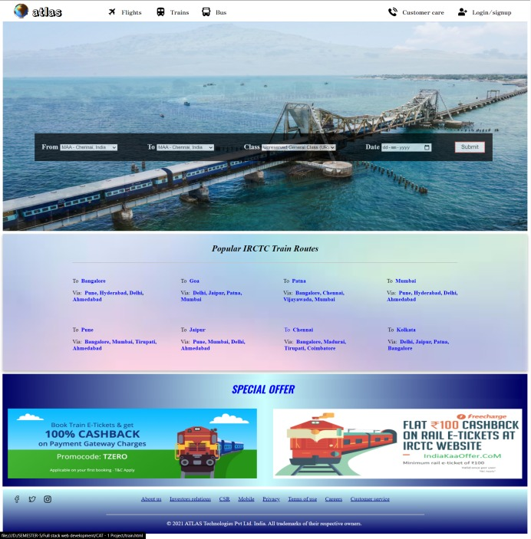

1. **Bus ticket booking page**

**HTML:**

<!DOCTYPE html>

<html>

<head>

<meta charset="utf-8">

<title>Book Bus</title>

<link rel="stylesheet" type="text/css" href="style.css">

<link href="https://fonts.googleapis.com/css2?family=Rampart+One&display=swap" rel="stylesheet">

<link href="https://fonts.googleapis.com/css2?family=Zen+Antique&display=swap" rel="stylesheet">

<link href="https://fonts.googleapis.com/css2?family=Oswald:wght@600&display=swap" rel="stylesheet">

<!-- Navigation bar-->

<header>

<div class="header">

<img style="height:45px ;" src="globe.png" alt = "logo">

<h1 style="margin-top: 5px;">atlas</h1>

<img style="height: 25px; margin-left: 300px; margin-top: -55px;" src="plane.png">

<a class="four" href="Home_page.html" style="margin-left: 340px; margin-top: -55px;" >Flights</a>

<img style="height: 25px; margin-left: 440px; margin-top: -55px;"src="train.png">

<a class="four" href="train.html" style="margin-left: 480px; margin-top: -55px;" >Trains</a>

<img style="height: 25px; margin-left: 570px; margin-top: -55px;"src="bus.png">

<a class="four" href="bus.html" style="margin-left: 610px; margin-top: -55px;" >Bus</a>

<img style="height: 25px; margin-left: 1305px; margin-top: -55px;"src="user.png">

<a class="four" href="login_signup.html" style="margin-left: 1345px; margin-top: -55px;" >Login/signup</a>

<img style="height: 25px; margin-left: 1105px; margin-top: -55px;"src="telephone-call.png">

<a class="four" href="customer_care.html" style="margin-left: 1145px; margin-top: -55px;" >Customer care</a>

</div>

</header>

</head>

<body>

<div id="cf">

<img class="bottom" src="https://wallup.net/wp-content/uploads/2016/04/06/359511-India-Taj_Mahal-Asian_architecture-love-landscape-water-reflection-sunset.jpg" />

<img class="top" src="https://www.gujarattourism.com/content/dam/gujrattourism/images/religious-sites/akshardham-temple/Akshardham-Temple-Banner.jpg" />

<img class="bottom" src="https://upload.wikimedia.org/wikipedia/commons/1/1f/Thiruvalluvar_Statue_At_Kanyakumari_%28197523127%29.jpeg">

<img class = "bottom" src="https://pix10.agoda.net/geo/city/3667/1_3667_02.jpg?s=1920x822">

<img class = "bottom" src="https://img.theculturetrip.com/wp-content/uploads/2018/02/8517681001_bebaf23525_k.jpg">

<div class="text-block">

<form style="display: inline-block;float: right;">

<label><b>From</b></label>

<select id="from", name="from">

<option value="chennai">Chennai</option>

<option value="bangalore">Coimbatore</option>

<option value="Hyderabad">Madurai</option>

<option value="Mumbai">Salem</option>

<option value="Delhi">Tiruneveli</option>

<option value="Delhi">Kanyakumari</option>

<option value="Delhi">Erode</option>

<option value="Delhi">Namakkal</option>

</select>&emsp;&emsp;&emsp;&emsp;&emsp;&emsp;

<label><b>To</b></label>

<select id="from", name="from">

<option value="chennai">Chennai</option>

<option value="bangalore">Coimbatore</option>

<option value="Hyderabad">Madurai</option>

<option value="Mumbai">Salem</option>

<option value="Delhi">Tiruneveli</option>

<option value="Delhi">Kanyakumari</option>

<option value="Delhi">Erode</option>

<option value="Delhi">Namakkal</option>

</select>&emsp;&emsp;&emsp;&emsp;&emsp;&emsp;

<label><b>Date</b></label>

<input type="date" name="return" value="date">&emsp;&emsp;&emsp;&emsp;&emsp;&emsp;

<label><b>Class</b></label>

<select id="class", name="class">

<option value="Semi sleeper - AC">Semi sleeper - AC</option>

<option value="Semi sleeper - Non AC">Semi sleeper - Non AC</option>

<option value="Sleeper - AC">Sleeper - AC</option>

<option value="Sleeper - Non AC">Sleeper - Non AC</option>

</select>&emsp;&emsp;&emsp;&emsp;&emsp;&emsp;

<input type="submit" class="button button3">

</form>

</div>

</div>

<section>

<div class="card" style="margin-top: 630px;">

<div class="container">

<h3 style="text-align: center; font-size: 25px;"><b><i>Top Tourist Bus Routes</i></b></h3><hr>

<center><p>Avail amazing deals, a huge choice of operators, instant refunds and 24x7 customer support on your bus tickets right here. Atlas has recently acquired AbhiBus, one of India's leading bus booking platforms. Enjoy the same seamless experience of Booking Bus Tickets on AbhiBus!</p></center><br>

<div>

<div>

<p><b><a class="five" href="">Bangalore To Ooty</a></b></p>

<p><b><a class="five" href="">Chennai To Bangalore</a></b></p>

<p><b><a class="five" href="">Pondichery To Chennai</a></b></p>

<p><b><a class="five" href="">Bangalore To Mangalore</a></b></p>

</div>

<div style="display: inline-block; float: right; margin-top: -153px;">

<p><b><a class="five" href="">Trivandran To Kozhikode</a></b></p>

<p><b><a class="five" href="">Chennai To Madurai</a></b></p>

<p><b><a class="five" href="">Pondichery To Tirupati</a></b></p>

<p><b><a class="five" href="">Coimbatore To Mangalore</a></b></p>

</div>

<div style="display: inline-block; float: right; margin-top: -153px; margin-right: 445px;">

<p><b><a class="five" href="">Trichy To Ooty</a></b></p>

<p><b><a class="five" href="">Chennai To Vizag</a></b></p>

<p><b><a class="five" href="">Mysore To Chennai</a></b></p>

<p><b><a class="five" href="">Bangalore To Kakinada</a></b></p>

</div>

<div style="display: inline-block; float: right; margin-top: -153px; margin-right: 310px;">

<p><b><a class="five" href="">Bangalore To Salem</a></b></p>

<p><b><a class="five" href="">Chennai To Coimbatore</a></b></p>

<p><b><a class="five" href="">Pondichery To Chitoor</a></b></p>

<p><b><a class="five" href="">Mysore To Mangalore</a></b></p>

</div>

</div><br>

</div>

</div>

</section>

<!-- Footer -->

<footer class="footer" style="margin-top: 12px;">

<br>

<div style="margin-bottom: -40px; margin-left: 30px;">

<img style="width: 20px;" src="facebook.png"> &emsp; <img style="width: 20px;" src="twitter.png"> &emsp; <img style="width: 20px;" src="instagram.png">

</div>

<div class="footer_ref">

<p><a class="one" href="">About us</a> &emsp; <a class="one" href="">Investors relations</a> &emsp; <a class="one" href="">CSR</a> &emsp; <a class="one" href="">Mobile</a> &emsp; <a class="one" href="">Privacy</a> &emsp; <a class="one" href="">Terms of use</a> &emsp; <a class="one" href="">Careers</a> &emsp; <a class="one" href="">Customer service</a> <br><br> </p>

</div><br><br><br><hr>

<p style="margin-left:470px; padding-bottom: 20px; color: white">&copy; 2021 ATLAS Technologies Pvt Ltd. India. All trademarks of their respective owners.</p>

</footer>

</body>

</html>

**Bus page:**

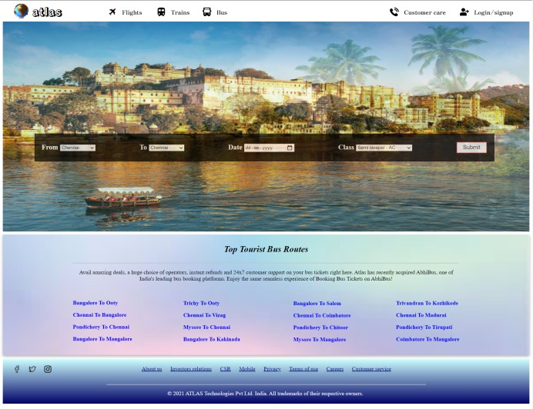

1. **Customer care page:**

**HTML:**

<!DOCTYPE html>

<html>

<head>

<meta charset="utf-8">

<title>customer_care</title>

<link rel="stylesheet" type="text/css" href="style.css">

<link href="https://fonts.googleapis.com/css2?family=Rampart+One&display=swap" rel="stylesheet">

<link href="https://fonts.googleapis.com/css2?family=Zen+Antique&display=swap" rel="stylesheet">

<link href="https://fonts.googleapis.com/css2?family=Oswald:wght@600&display=swap" rel="stylesheet">

<!-- Navigation bar-->

<header>

<div class="header">

<img style="height:45px ;" src="globe.png" alt = "logo">

<h1 style="margin-top: 5px;">atlas</h1>

<img style="height: 25px; margin-left: 300px; margin-top: -55px;" src="plane.png">

<a class="four" href="Home_page.html" style="margin-left: 340px; margin-top: -55px;" >Flights</a>

<img style="height: 25px; margin-left: 440px; margin-top: -55px;"src="train.png">

<a class="four" href="train.html" style="margin-left: 480px; margin-top: -55px;" >Trains</a>

<img style="height: 25px; margin-left: 570px; margin-top: -55px;"src="bus.png">

<a class="four" href="bus.html" style="margin-left: 610px; margin-top: -55px;" >Bus</a>

<img style="height: 25px; margin-left: 1305px; margin-top: -55px;"src="user.png">

<a class="four" href="login_signup.html" style="margin-left: 1345px; margin-top: -55px;" >Login/signup</a>

<img style="height: 25px; margin-left: 1105px; margin-top: -55px;"src="telephone-call.png">

<a class="four" href="" style="margin-left: 1145px; margin-top: -55px;" >Customer care</a>

</div>

</header>

<style>

.Container {

position: relative;

font-family: Arial;

}

.Text-block {

position: absolute;

bottom: 100px;

right: 900px;

background-color: black;

color: white;

padding-left: 20px;

padding-right: 20px;

opacity: 0.7;

padding-bottom: 20px;

}

.button {

background-color: #4CAF50; /* Green */

border: none;

color: white;

padding: 16px 32px;

text-align: center;

text-decoration: none;

display: inline-block;

font-size: 16px;

margin: 4px 2px;

transition-duration: 0.4s;

cursor: pointer;

}

.button2 {

background-color: white;

color: black;

border: 2px solid #008CBA;

}

.button2:hover {

background-color: #008CBA;

color: white;

}

</style>

</head>

<body>

<div class="Container">

<img style="height: 690px; width: 100%; margin-top: -15px;" src="https://www.pixelstalk.net/wp-content/uploads/2015/05/Plane-on-the-beach.jpg">

<div class="Text-block">

<h3><b>Thanks for your interest in ATLAS</b></h3>

<p>For queries write to us.</p>

<form>

<label for="name"><b>Name:</b></label>&emsp;&emsp;

<input type="text" name="name" placeholder=" Enter Name" style="height: 30px; border-radius: 5px;" required **pattern="[a-zA-Z ]{1,15}", title="Only Alphabets."** size="40"><br><br>

<label for="email"><b>Email:</b></label>&emsp;&emsp;

<input type="text" placeholder=" Enter Email" name="email" style="height: 30px; border-radius: 5px;" required **pattern="[a-z0-9._%+-]+@[a-z0-9.-]+\.[a-z]{2,4}$" title="Enter a valid E-mail address." size="40"**><br><br>

<label for="text"><b>Queries:</b></label>&emsp;

<input type="text" name="query" placeholder=" Enter your queries" style="height: 70px; border-radius: 5px;" required **pattern="[a-zA-Z0-9 ]{1,100}"**, title="Only Alphabets." size="40"><br><br>

<input class="button button3" style="margin-left: 153px; padding: 10px 20px; border-radius: 5px;" type="submit" name="submit">

</form><br>

<center>

<p>Reach us out here:</p>

<p><b>Mail:</b> atlas.travel@gmail.com</p>

<p><b>Phone no:</b> (+91) 9546218964</p>

</center>

</div>

</div>

<!-- Footer -->

<footer class="footer" style="margin-top: 0px;">

<br>

<div style="margin-bottom: -40px; margin-left: 30px;">

<img style="width: 20px;" src="facebook.png"> &emsp; <img style="width: 20px;" src="twitter.png"> &emsp; <img style="width: 20px;" src="instagram.png">

</div>

<div class="footer_ref">

<p><a class="one" href="">About us</a> &emsp; <a class="one" href="">Investors relations</a> &emsp; <a class="one" href="">CSR</a> &emsp; <a class="one" href="">Mobile</a> &emsp; <a class="one" href="">Privacy</a> &emsp; <a class="one" href="">Terms of use</a> &emsp; <a class="one" href="">Careers</a> &emsp; <a class="one" href="">Customer service</a> <br><br> </p>

</div><br><br><br><hr>

<p style="margin-left:470px; padding-bottom: 20px; color: white">&copy; 2021 ATLAS Technologies Pvt Ltd. India. All trademarks of their respective owners.</p>

</footer>

</body>

</html>

**Customer care page:**

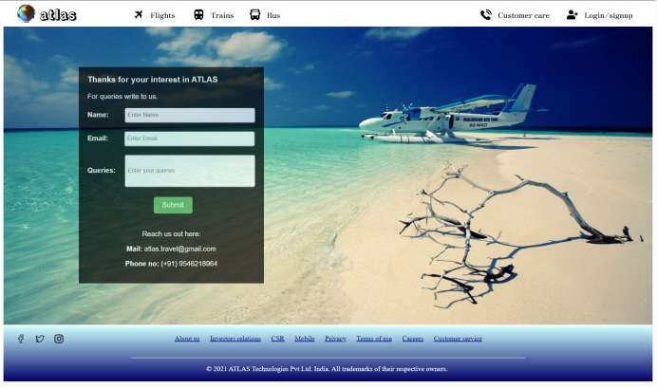

**Validation done through regular expression pattern, for verification refer the above code which are highlighted.**

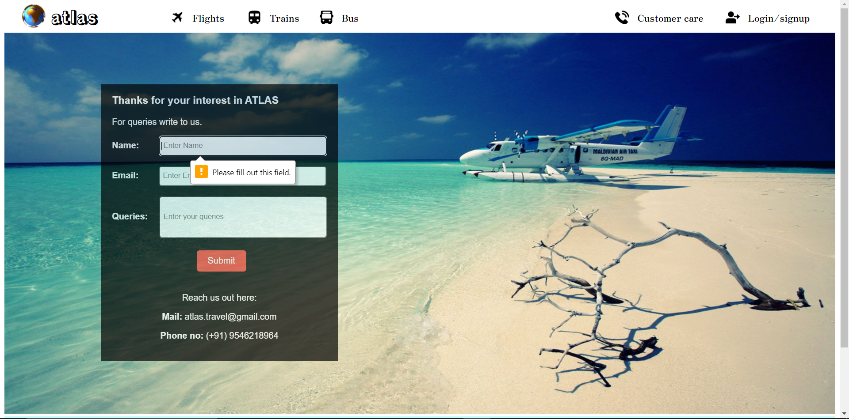

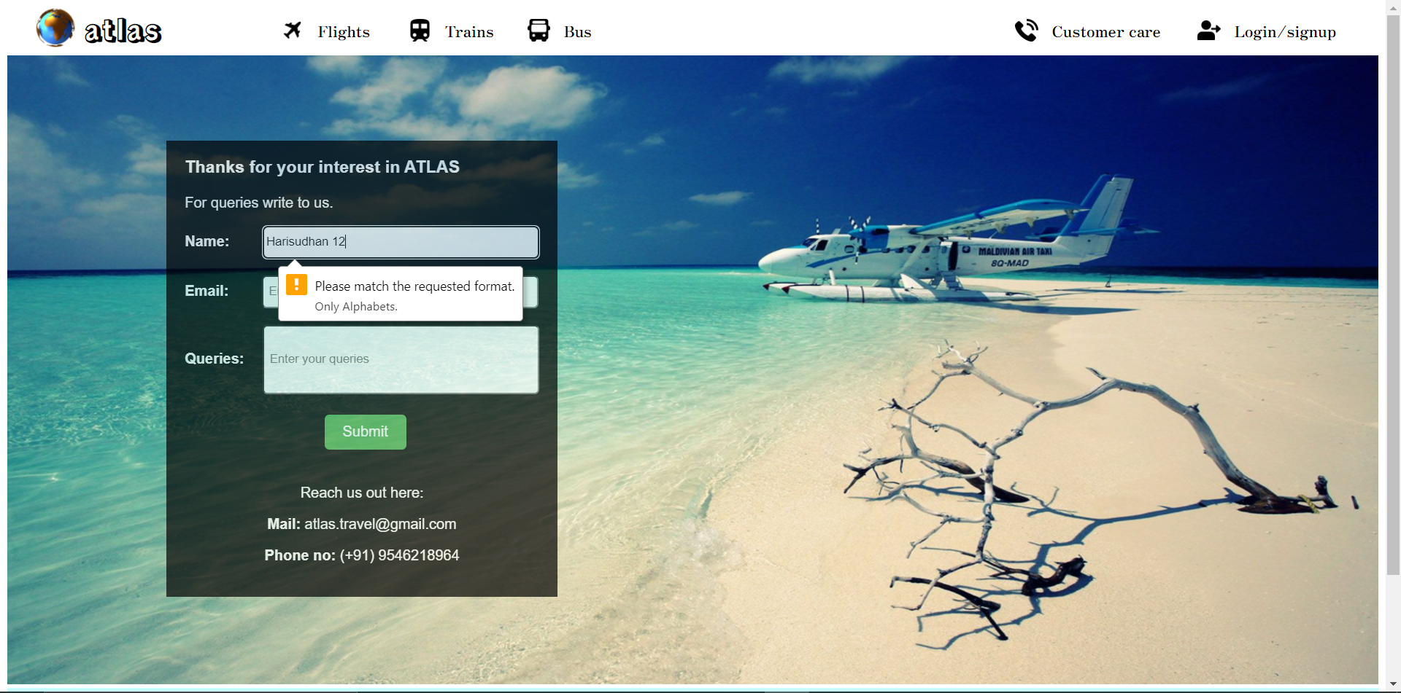

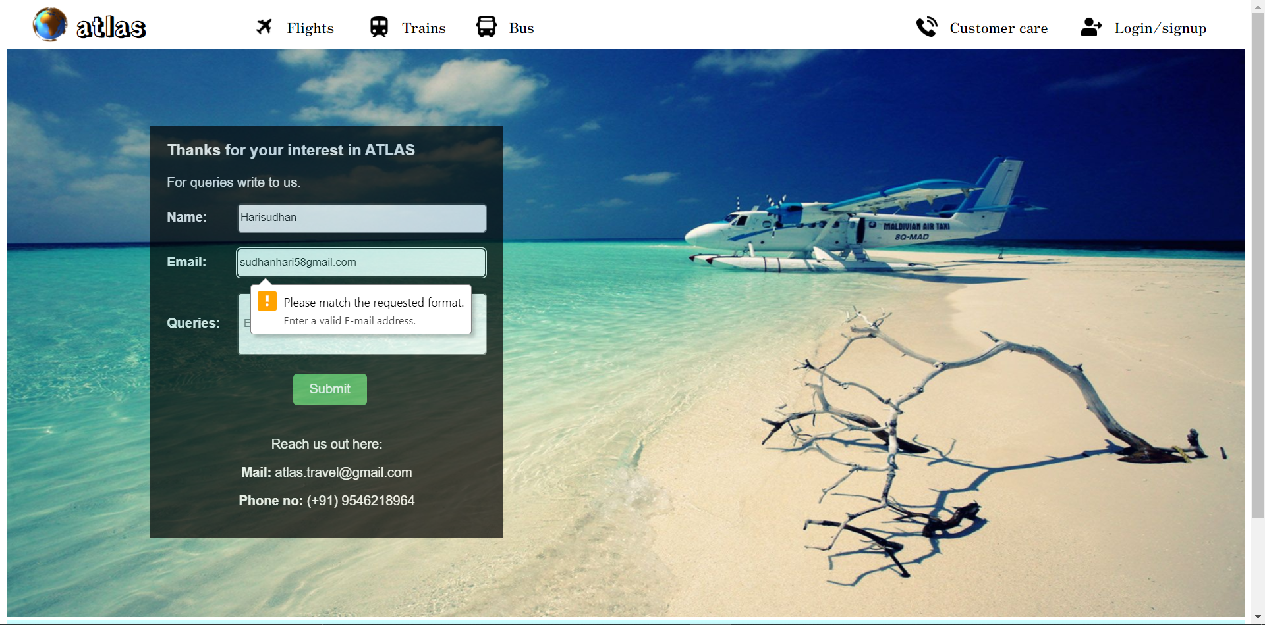

1. **Sign up page**

**HTML:**

<!DOCTYPE html>

<html>

<head>

<meta charset="utf-8">

<title>Login/Signup</title>

<link rel="stylesheet" type="text/css" href="style.css">

<link href="https://fonts.googleapis.com/css2?family=Rampart+One&display=swap" rel="stylesheet">

<link href="https://fonts.googleapis.com/css2?family=Zen+Antique&display=swap" rel="stylesheet">

<link href="https://fonts.googleapis.com/css2?family=Oswald:wght@600&display=swap" rel="stylesheet">

<script src="javascript_signup.js"></script>

<!-- Navigation bar-->

<header>

<div class="header">

<img style="height:45px ;" src="globe.png" alt = "logo">

<h1 style="margin-top: 5px;">atlas</h1>

<img style="height: 25px; margin-left: 300px; margin-top: -55px;" src="plane.png">

<a class="four" href="Home_page.html" style="margin-left: 340px; margin-top: -55px;" >Flights</a>

<img style="height: 25px; margin-left: 440px; margin-top: -55px;"src="train.png">

<a class="four" href="train.html" style="margin-left: 480px; margin-top: -55px;" >Trains</a>

<img style="height: 25px; margin-left: 570px; margin-top: -55px;"src="bus.png">

<a class="four" href="bus.html" style="margin-left: 610px; margin-top: -55px;" >Bus</a>

<img style="height: 25px; margin-left: 1305px; margin-top: -55px;"src="user.png">

<a class="four" href="login_signup.html" style="margin-left: 1345px; margin-top: -55px;" >Login/signup</a>

<img style="height: 25px; margin-left: 1105px; margin-top: -55px;"src="telephone-call.png">

<a class="four" href="customer_care.html" style="margin-left: 1145px; margin-top: -55px;" >Customer care</a>

</div>

</header>

<style>

body {font-family: Arial, Helvetica, sans-serif;}

* {box-sizing: border-box}

/* Full-width input fields */

input[type=text], input[type=password] {

width: 100%;

padding: 15px;

margin: 5px 0 22px 0;

display: inline-block;

border: none;

background: #f1f1f1;

}

input[type=text]:focus, input[type=password]:focus {

background-color: #ddd;

outline: none;

}

hr {

border: 1px solid #f1f1f1;

margin-bottom: 25px;

}

/* Set a style for all buttons */

button {

background-color: #04AA6D;

color: white;

padding: 14px 20px;

margin: 8px 0;

border: none;

cursor: pointer;

width: 100%;

opacity: 0.9;

}

button:hover {

opacity:1;

}

/* Extra styles for the cancel button */

.cancelbtn {

padding: 14px 20px;

background-color: #f44336;

}

/* Float cancel and signup buttons and add an equal width */

.cancelbtn, .signupbtn {

float: left;

width: 50%;

}

/* Add padding to container elements */

.container {

padding: 16px;

margin-top: -15px;

}

/* Clear floats */

.clearfix::after {

content: "";

clear: both;

display: table;

}

/* Change styles for cancel button and signup button on extra small screens */

@media screen and (max-width: 300px) {

.cancelbtn, .signupbtn {

width: 100%;

}

}

</style>

</head>

<body>

<form action="/action_page.php" style="border:1px solid #ccc">

<div class="container">

<h2>Sign Up</h2>

<p>Please fill in this form to create an account.</p>

<hr>

<label for="email"><b>Email</b></label>

<input type="text" placeholder="Enter Email" name="email" required **pattern="[a-z0-9._%+-]+@[a-z0-9.-]+\.[a-z]{2,4}$" title="Enter a valid E-mail address."**>

<label for="psw"><b>Password</b></label>

<input type="password" placeholder="Enter Password" name="psw" required **pattern="(?=.*\d)(?=.*[a-z])(?=.*[A-Z]).{8,}"** **title="Must contain at least one number and one uppercase and lowercase letter, and at least 8 or more characters"**>

<label for="psw-repeat"><b>Repeat Password</b></label>

<input type="password" placeholder="Repeat Password" name="psw-repeat" required>

<label>

<input type="checkbox" checked="checked" name="remember" style="margin-bottom:15px"> Remember me

</label>

<p>By creating an account you agree to our <a href="#" style="color:dodgerblue">Terms & Privacy</a>.</p>

<p><b>Already having an account</b> <a style="color:dodgerblue" href="login.html">Click Here</a></p>

<div class="clearfix">

<button type="button" class="cancelbtn">Cancel</button>

<button type="submit" class="signupbtn">Sign Up</button>

</div>

</div>

</form>

<!-- Footer -->

<footer class="footer" style="margin-top: 2px;">

<br>

<div style="margin-bottom: -40px; margin-left: 30px;">

<img style="width: 20px;" src="facebook.png"> &emsp; <img style="width: 20px;" src="twitter.png"> &emsp; <img style="width: 20px;" src="instagram.png">

</div>

<div class="footer_ref">

<p><a class="one" href="">About us</a> &emsp; <a class="one" href="">Investors relations</a> &emsp; <a class="one" href="">CSR</a> &emsp; <a class="one" href="">Mobile</a> &emsp; <a class="one" href="">Privacy</a> &emsp; <a class="one" href="">Terms of use</a> &emsp; <a class="one" href="">Careers</a> &emsp; <a class="one" href="">Customer service</a> <br><br> </p>

</div><br><br><br><hr>

<p style="margin-left:470px; padding-bottom: 20px; color: white">&copy; 2021 ATLAS Technologies Pvt Ltd. India. All trademarks of their respective owners.</p>

</footer>

</body>

</html>

**Signup page**

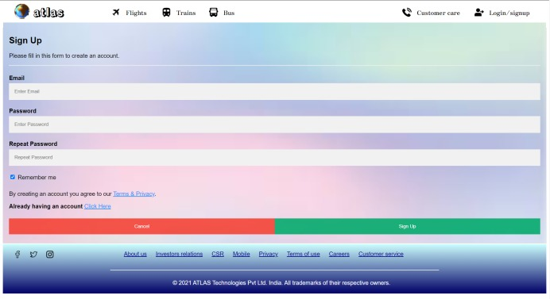

**Validation done through regular expression pattern, for verification refer the above code which are highlighted.**

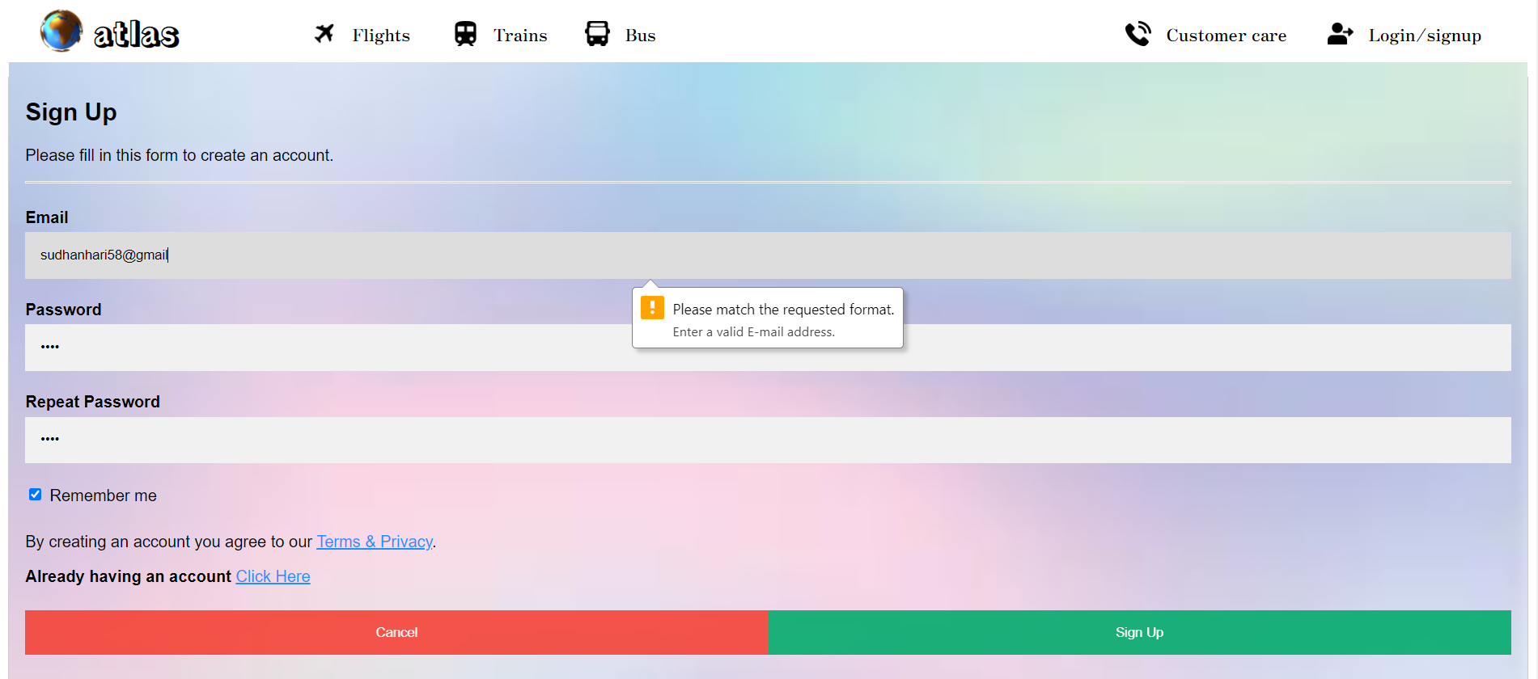

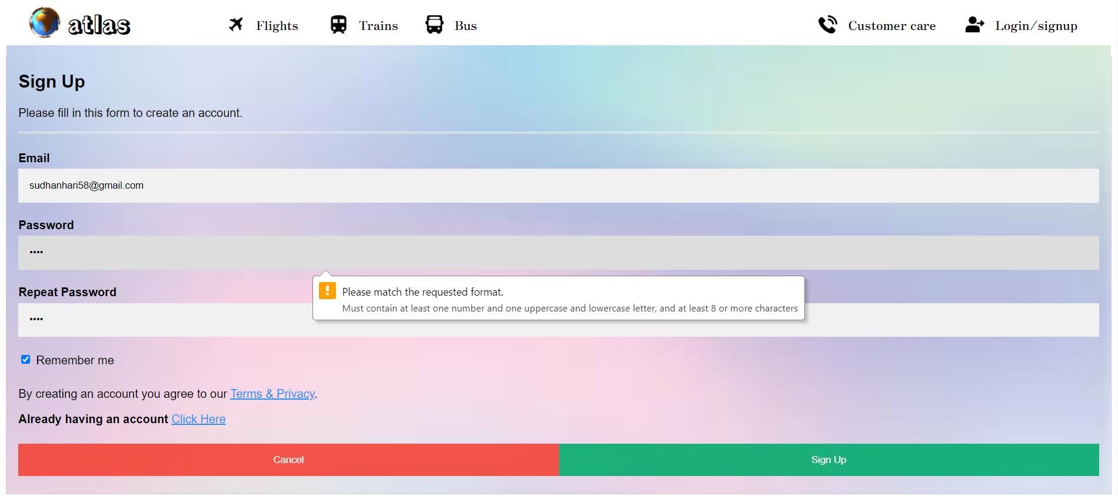

1. **Login page**

**HTML:**

<!DOCTYPE html>

<html>

<head>

<meta charset="utf-8">

<title>Login</title>

<link rel="stylesheet" type="text/css" href="style.css">

<link href="https://fonts.googleapis.com/css2?family=Rampart+One&display=swap" rel="stylesheet">

<link href="https://fonts.googleapis.com/css2?family=Zen+Antique&display=swap" rel="stylesheet">

<link href="https://fonts.googleapis.com/css2?family=Oswald:wght@600&display=swap" rel="stylesheet">

<!-- Navigation bar-->

<header>

<div class="header">

<img style="height:45px ;" src="globe.png" alt = "logo">

<h1 style="margin-top: 5px;">atlas</h1>

<img style="height: 25px; margin-left: 300px; margin-top: -55px;" src="plane.png">

<a class="four" href="Home_page.html" style="margin-left: 340px; margin-top: -55px;" >Flights</a>

<img style="height: 25px; margin-left: 440px; margin-top: -55px;"src="train.png">

<a class="four" href="train.html" style="margin-left: 480px; margin-top: -55px;" >Trains</a>

<img style="height: 25px; margin-left: 570px; margin-top: -55px;"src="bus.png">

<a class="four" href="bus.html" style="margin-left: 610px; margin-top: -55px;" >Bus</a>

<img style="height: 25px; margin-left: 1305px; margin-top: -55px;"src="user.png">

<a class="four" href="login_signup.html" style="margin-left: 1345px; margin-top: -55px;" >Login/signup</a>

<img style="height: 25px; margin-left: 1105px; margin-top: -55px;"src="telephone-call.png">

<a class="four" href="customer_care.html" style="margin-left: 1145px; margin-top: -55px;" >Customer care</a>

</div>

</header>

<style>

body {font-family: Arial, Helvetica, sans-serif;}

* {box-sizing: border-box}

/* Full-width input fields */

input[type=text], input[type=password] {

width: 100%;

padding: 15px;

margin: 5px 0 22px 0;

display: inline-block;

border: none;

background: #f1f1f1;

}

input[type=text]:focus, input[type=password]:focus {

background-color: #ddd;

outline: none;

}

hr {

border: 1px solid #f1f1f1;

margin-bottom: 25px;

}

/* Set a style for all buttons */

button {

background-color: #04AA6D;

color: white;

padding: 14px 20px;

margin: 8px 0;

border: none;

cursor: pointer;

width: 100%;

opacity: 0.9;

}

button:hover {

opacity:1;

}

/* Extra styles for the cancel button */

.cancelbtn {

padding: 14px 20px;

background-color: #f44336;

}

/* Float cancel and signup buttons and add an equal width */

.cancelbtn, .signupbtn {

float: left;

width: 50%;

}

/* Add padding to container elements */

.container {

padding: 16px;

margin-top: -15px;

}

/* Clear floats */

.clearfix::after {

content: "";

clear: both;

display: table;

}

/* Change styles for cancel button and signup button on extra small screens */

@media screen and (max-width: 300px) {

.cancelbtn, .signupbtn {

width: 100%;

}

}

</style>

</head>

<body>

<form action="/action_page.php" style="border:1px solid #ccc">

<div class="container">

<h2>Login</h2>

<p>Please fill in this form to create an account.</p>

<hr>

<label for="email"><b>Email</b></label>

<input type="text" placeholder="Enter Email" name="email" required **pattern="[a-z0-9._%+-]+@[a-z0-9.-]+\.[a-z]{2,4}$" title="Enter a valid E-mail address."**>

<label for="psw"><b>Password</b></label>

<input type="password" placeholder="Enter Password" name="psw" required **pattern="(?=.*\d)(?=.*[a-z])(?=.*[A-Z]).{8,}" title="Must contain at least one number and one uppercase and lowercase letter, and at least 8 or more characters"**>

<label>

<input type="checkbox" checked="checked" name="remember" style="margin-bottom:15px"> Remember me

</label>

<p>By creating an account you agree to our <a href="#" style="color:dodgerblue">Terms & Privacy</a>.</p>

<div class="clearfix">

<button type="button" class="cancelbtn">Cancel</button>

<button type="submit" class="signupbtn">Sign Up</button>

</div>

<div style="margin-left: 450px">

<img style="height: 40px; margin-top: 15px; margin-left: 100px" src="trust.png">

<p>Trusted over by 100 million Indians</p>

</div>

<div style="display: inline-block; float: right; margin-top: -105px; margin-right: 450px;">

<img style="height: 40px; margin-top: 10px; margin-left: 70px" src="lock.png">

<p>Fast and secure payments</p>

</div>

</div>

</form>

<!-- Footer -->

<footer class="footer" style="margin-top: 2px;">

<br>

<div style="margin-bottom: -40px; margin-left: 30px;">

<img style="width: 20px;" src="facebook.png"> &emsp; <img style="width: 20px;" src="twitter.png"> &emsp; <img style="width: 20px;" src="instagram.png">

</div>

<div class="footer_ref">

<p><a class="one" href="">About us</a> &emsp; <a class="one" href="">Investors relations</a> &emsp; <a class="one" href="">CSR</a> &emsp; <a class="one" href="">Mobile</a> &emsp; <a class="one" href="">Privacy</a> &emsp; <a class="one" href="">Terms of use</a> &emsp; <a class="one" href="">Careers</a> &emsp; <a class="one" href="">Customer service</a> <br><br> </p>

</div><br><br><br><hr>

<p style="margin-left:470px; padding-bottom: 20px; color: white">&copy; 2021 ATLAS Technologies Pvt Ltd. India. All trademarks of their respective owners.</p>

</footer>

</body>

</html>

**Login page:**

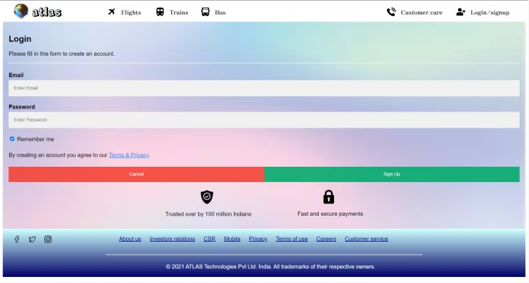

**Validation done through regular expression pattern, for verification refer the above code which are highlighted.**

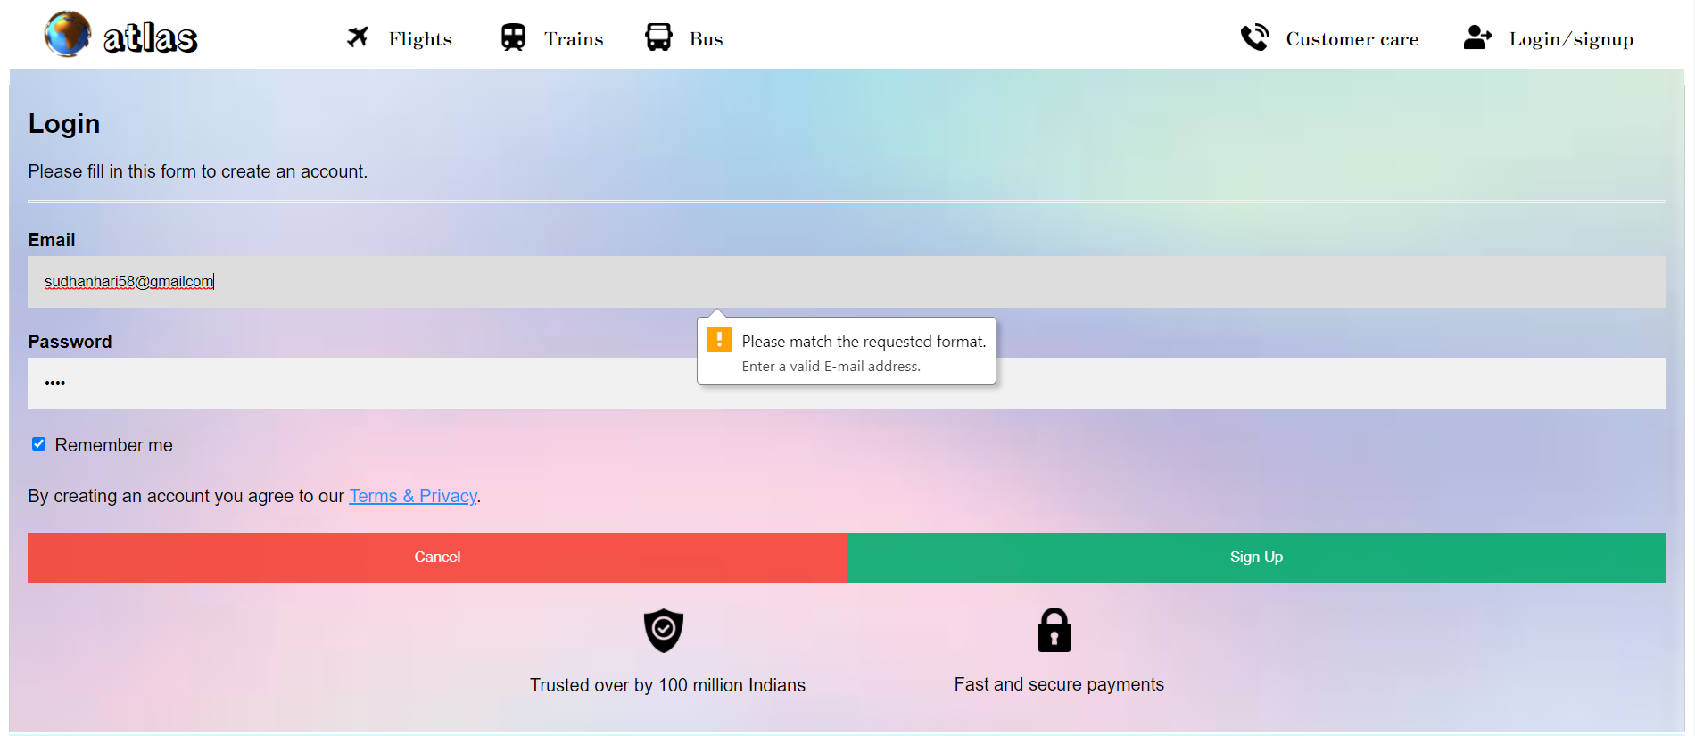

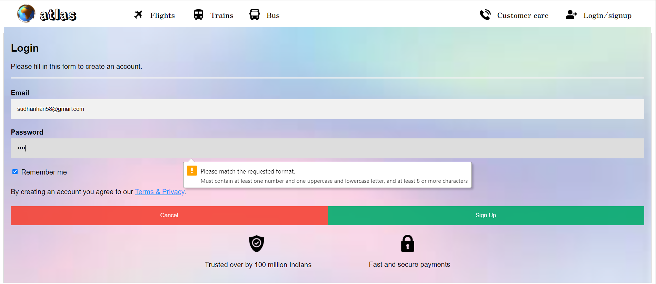

1. **Flight selection page:**

**HTML:**

<html>

<head>

<meta charset="utf-8">

<title>Select flight</title>

<link rel="stylesheet" type="text/css" href="c.css">

<link rel="stylesheet" type="text/css" href="style.css">

<link href="https://fonts.googleapis.com/css2?family=Rampart+One&display=swap" rel="stylesheet">

<link href="https://fonts.googleapis.com/css2?family=Zen+Antique&display=swap" rel="stylesheet">

<link href="https://fonts.googleapis.com/css2?family=Oswald:wght@600&display=swap" rel="stylesheet">

<!-- Navigation bar-->

<header>

<div class="header" style="background-color: white;">

<img style="height:45px ; margin-top: 15px; margin-left: 30px" src="globe.png" alt = "logo">

<h1 style="margin-top: 15px;">atlas</h1>

<img style="height: 25px; margin-left: 250px; margin-top: -50px;" src="plane.png">

<a class="four" href="Home_page.html" style="margin-left: 290px; margin-top: -50px;" >Flights</a>

<img style="height: 25px; margin-left: 390px; margin-top: -50px;"src="train.png">

<a class="four" href="train.html" style="margin-left: 430px; margin-top: -50px;" >Trains</a>

<img style="height: 25px; margin-left: 520px; margin-top: -50px;"src="bus.png">

<a class="four" href="bus.html" style="margin-left: 560px; margin-top: -50px;" >Bus</a>

<img style="height: 25px; margin-left: 1155px; margin-top: -50px;"src="user.png">

<a class="four" href="login_signup.html" style="margin-left: 1195px; margin-top: -50px;" >Login/signup</a>

<img style="height: 25px; margin-left: 955px; margin-top: -50px;"src="telephone-call.png">

<a class="four" href="customer_care.html" style="margin-left: 995px; margin-top: -50px;" >Customer care</a>

</div>

</header>

<style type="text/css">

.flight1{

border-style: inset;

border-radius: 15px;

border-width: 2px;

background-color: rgb(135,206,235);

font-family: Courier New;}

.position{

height: 70px;

width: 925px;

top: 50px;

position: relative;

}

.position1{

height: 70px;

width: 925px;

top: 75px;

position: relative;

}

.position2{

height: 70px;

width: 925px;

top: 100px;

position: relative;

}

.position3{

height: 70px;

width: 925px;

top: 125px;

position: relative;

}

.flposition{

position: relative;

top: -10px;

left: 80px;

}

.tiposition{

position: relative;

top: 5px;

left: 120px;

}

.destination{

position: relative;

top: 30px;

left: -120px;

}

.rateposition1{

position: relative;

top: 5px;

left: 125px;

}

.rateposition2{

position: relative;

top: 5px;

left: 135px;

}

.rateposition3{

position: relative;

top: 5px;

left: 105px;

}

.rateposition4{

position: relative;

top: 5px;

left: 95px;

}

.book {

border: none;

color: white;

padding: 15px 32px;

text-align: center;

text-decoration: none;

display: inline-block;

font-size: 16px;

margin: 4px 2px;

cursor: pointer;

border-radius: 10px;

background-color: rgb(255,126,0);

position: relative;

top: 5px;

left: 200px;

}

.align1{

position: relative;

left: 190px;

}

.align3{

position: relative;

left: 173px;

}

.align4{

position: relative;

left: 155px;

}

div

{

float: left;

}

.advertisment{

float: right;

}

</style>

</head>

<body style="background-image: url('background.jpg');">

<img src="adver 1.jpg" class="advertisment">

<div class="flight1 position" style="background-image: url('indigo.png');background-repeat: no-repeat;background-size: 55px 60 px;">

<div id='flname'class='flposition'>

<p>Indigo</p>

<p>2E3451</p>

</div>

<div id="time" class="tiposition">

<p><b>14:15</b> ---------------- <b>17:00</b></p>

</div>

<div id="destination" class="destination">

<p><b><center>Chennai to New Delhi</center></b></p>

</div>

<div id='rate' class='rateposition1'>

<p><b>Rs.7399</b></p>

</div>

<div id="button" class="buttonposition">

<!--<button class="book align1">BOOK</button>-->

<a class="book align1" href="passenger details.html">BOOK</a>

</div>

</div>

<div class="flight1 position1" style="background-image:url('vistara.png');background-repeat: no-repeat;background-size: 55px 60px;">

<div id='flname'class='flposition'>

<p>Vistara</p>

<p>673AB7</p>

</div>

<div id="time" class="tiposition">

<p><b>1:00</b> ---------------- <b>3:15</b></p>

</div>

<div id="destination" class="destination">

<p><b><center>Chennai to New Delhi</center></b></p>

</div>

<div id='rate' class='rateposition2'>

<p><b>Rs.8000</b></p>

</div>

<div id="button" class="buttonposition">

<!--<button class="book align2">BOOK</button>-->

<a class="book align2" href="passenger details.html">BOOK</a>

</div>

</div>

<div class="flight1 position2" style="background-image: url('spicejet.png');background-repeat: no-repeat;background-size: 55px 60px;">

<div id='flname'class='flposition'>

<p>Spicejet</p>

<p>SP1234</p>

</div>

<div id="time" class="tiposition">

<p><b>11:00</b> ---------------- <b>13:15</b></p>

</div>

<div id="destination" class="destination">

<p><b><center>Chennai to New Delhi</center></b></p>

</div>

<div id='rate' class='rateposition3'>

<p><b>Rs.7999</b></p>

</div>

<div id="button" class="buttonposition">

<!--<button class="book align3">BOOK</button>-->

<a class="book align3" href="passenger details.html">BOOK</a>

</div>

</div>

<div class="flight1 position3" style="background-image: url('air india.png');background-repeat: no-repeat;background-size: 55px 60px;">

<div id='flname'class='flposition'>

<p>Air India</p>

<p>AI6531</p>

</div>

<div id="time" class="tiposition">

<p><b>15:00</b> ---------------- <b>18:45</b></p>

</div>

<div id="destination" class="destination">

<p><b><center>Chennai to New Delhi</center></b></p>

</div>

<div id='rate' class='rateposition4'>

<p><b>Rs.12999</b></p>

</div>

<div id="button" class="buttonposition">

<!--<button class="book align4">BOOK</button>-->

<a class="book align4" href="passenger details.html">BOOK</a>

</div>

</div>

<img src="adver 2.png" class="advertisment">

</body>

</html>

**CSS:**

.header img{

float: left;

position: relative;

display: inline-block;

cursor: pointer;

margin-right: 10px;

}

.header a{

float: left;

margin-left: 0px;

position: relative;

display: inline-block;

font-size: 17px;

text-decoration: none;

font-family: 'Zen Antique', serif;

}

a.four:link {color:#ff0000;}

a.four:visited {color:black;}

a.four:hover {font-family:monospace;}

a.four:hover {color:red;}

.header h1{

font-family: 'Rampart One', cursive;

}

#cf {

position: relative;

}

#cf img {

animation-name: cf3FadeInOut;

animation-timing-function: ease-in-out;

/* if you only want to cycle a finite amount of times,

simply change 'infinite' with # of iterations you need */

animation-iteration-count: infinite;

animation-duration: 50s;

animation-direction: alternate; /* not strictly necessary */

position:absolute;

height: 600px;

width: 100%;

}

#cf img:nth-of-type(1) {

animation-delay: 40s;

}

#cf img:nth-of-type(2) {

animation-delay: 30s;

}

#cf img:nth-of-type(3) {

animation-delay: 20s;

}

#cf img:nth-of-type(4) {

animation-delay: 10s;

}

#cf img:nth-of-type(5) {

animation-delay: 0s;

}

@keyframes cf3FadeInOut {

/* distributing times evenly */

0% {

opacity: 1;

}

25% {

opacity: 0;

}

75% {

opacity: 0;

}

100% {

opacity: 1;

}

}

#cf{

margin-top: -15px;

}

.text-block {

position: absolute;

bottom: -400px;

right: 100px;

background-color: black;

color: white;

padding-left: 20px;

padding-right: 20px;

padding-top: 20px;

padding-bottom: 20px;

opacity: 0.7;

font-size: 20px;

}

.button {

background-color: #4CAF50; /* Green */

border: none;

color: white;

padding: 5px 16px;

text-align: center;

text-decoration: none;

display: inline-block;

font-size: 16px;

margin: 4px 2px;

transition-duration: 0.4s;

cursor: pointer;

}

.button3 {

background-color: white;

color: black;

border: 2px solid #f44336;

}

.button3:hover {

background-color: #f44336;

color: white;

}

.offerimage{

background-image: linear-gradient(to right, #000066, #ccffff , #000066);

display: inline-block;

float: right;

padding-right: 15px;

}

.offer img{

padding: 10px;

box-shadow: 8px 10px 10px #888888;

}

#offertitle{

font-family: 'Oswald', sans-serif;

background-color: #B0C4DE;

background-image: linear-gradient(to right, #000066, #ccffff , #000066);

}

div.rotate_right {

float: left;

-ms-transform: rotate(7deg); /* IE 9 */

-webkit-transform: rotate(7deg); /* Safari */

transform: rotate(7deg);

margin-top: 40px;

margin-left: 55px;

}

div.rotate_left {

float: left;

-ms-transform: rotate(-8deg); /* IE 9 */

-webkit-transform: rotate(-8deg); /* Safari */

transform: rotate(-8deg);

margin-left: 55px;

margin-top: 40px;

}

.caption{

text-align: center;

}

.footer{

background-image: linear-gradient(#ccffff , #000066);

margin-top: 680px;

}

.footer_ref{

display: inline-block;

float: right;

margin-right: 380px;

}

a.one:link {color:#ff0000;}

a.one:visited {color:#00008B;}

a.one:hover {color: white}

.footer img{

cursor: pointer;

}

.footer hr{

width: 910px;

}

**Flight selection page:**

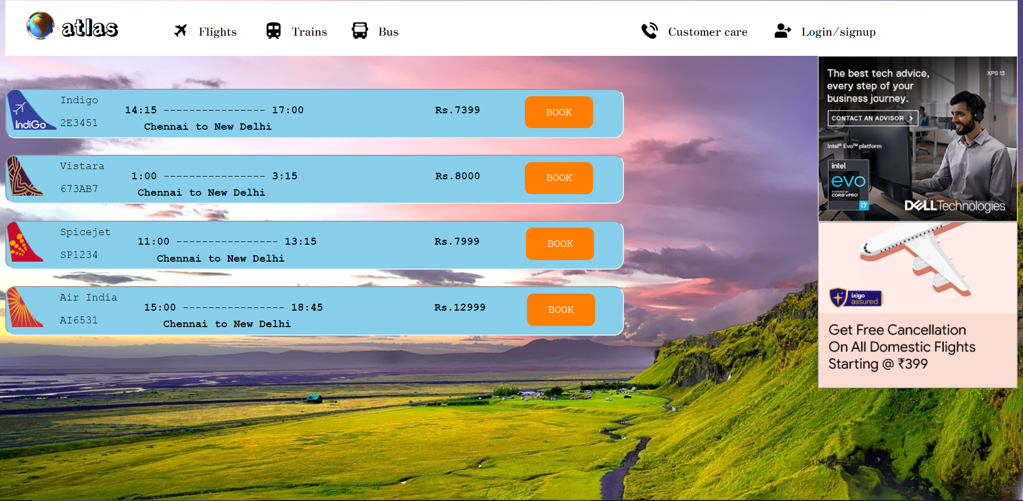

1. **Passenger details page:**

**HTML:**

<!DOCTYPE html>

<html>

<head>

<meta charset="utf-8">

<title>passenger details</title>

<link rel="stylesheet" type="text/css" href="c.css">

<link href="https://fonts.googleapis.com/css2?family=Rampart+One&display=swap" rel="stylesheet">

<link href="https://fonts.googleapis.com/css2?family=Zen+Antique&display=swap" rel="stylesheet">

<link href="https://fonts.googleapis.com/css2?family=Oswald:wght@600&display=swap" rel="stylesheet">

<!-- Navigation bar-->

<header>

<div class="header">

<img style="height:45px ; margin-left: 30px;" src="globe.png" alt = "logo">

<h1 style="margin-top:-30px;">atlas</h1>

<img style="height: 25px; margin-left: 250px; margin-top: -30px;" src="plane.png">

<a class="four" href="Home_page.html" style="margin-left: 290px; margin-top: -30px;" >Flights</a>

<img style="height: 25px; margin-left: 390px; margin-top: -30px;"src="train.png">

<a class="four" href="train.html" style="margin-left: 430px; margin-top: -30px;" >Trains</a>

<img style="height: 25px; margin-left: 520px; margin-top: -30px;"src="bus.png">

<a class="four" href="bus.html" style="margin-left: 560px; margin-top: -30px;" >Bus</a>

<img style="height: 25px; margin-left: 1155px; margin-top: -30px;"src="user.png">

<a class="four" href="login_signup.html" style="margin-left: 1195px; margin-top: -30px;" >Login/signup</a>

<img style="height: 25px; margin-left: 955px; margin-top: -30px;"src="telephone-call.png">

<a class="four" href="customer_care.html" style="margin-left: 995px; margin-top: -30px;" >Customer care</a>

</div>

</header>

<style type="text/css">

*{

margin: 0;

padding: 0;

}

body{

background-image: url("background2.jpg");

margin-top: 40px;

background-position: center;

background-size: cover;

font-family: sans-serif;

}

.regform{

width: 800px;

background-color: rgb(0, 0, 0,0.6);

margin: auto;

color: #FFFFFF;

padding: 10px 0px 10px 0px;

text-align: center;

border-radius: 15px 15px 0px 0px;

font-size: 20px;

margin-top: 80px;

}

.main{

background-color: rgb(0, 0, 0,0.5);

width: 800px;

margin:auto;

margin-bottom: 50px;

}

form{

padding: 10px;

}

#name{

width: 100%;

height: 100px;

}

.name{

margin-left: 25px;

margin-top: 30px;

width: 125px;

color: white;

font-size: 18px;

font-weight: 700;

}

.firstname{

position: relative;

left: 200px;

top: -37px;

line-height: 40px;

border-radius: 8px;

padding: 0 22px;

font-size: 16px;

}

.lastname{

position: relative;

left: 417px;

top: -80px;

line-height: 40px;

border-radius: 8px;

padding: 0 22px;

font-size: 16px;

color: #555;

}

.firstlabel{

position: relative;

color: #E5E5E5;

text-transform: capitalize;

font-size: 14px;

left: 203px;

top: -45px;

}

.lastlabel{

position: relative;

color: #E5E5E5;

text-transform: capitalize;

font-size: 14px;

left:492px;

top:-76px;

}

.company{

position: relative;

left: 200px;

top: -37px;

line-height: 40px;

width: 480px;

border-radius: 8px;

padding: 0 22px;

font-size: 16px;

color: #555;

}

.email{

position:relative;

left:200px;

top:-37px;

line-height: 40px;

width:480px;

border-radius: 6px;

padding: 0 22px;

font-size: 16px;

color: #555;

}

.code{

position:relative;

left:200px;

top:-37px;

line-height: 40px;

width:95px;

border-radius: 6px;

padding: 0 22px;

font-size: 16px;

color: #555;

}

.number{

position:relative;

left:200px;

top:-37px;

line-height: 40px;

width:255px;

border-radius: 6px;

padding: 0 22px;

font-size: 16px;

color: #555;

}

.area-code{

position:relative;

color:#E5E5E5;

text-transform:capitalize;

font-size:16px;

left:54px;

top:-4px;

}

.phone-number{

position:relative;

color:#E5E5E5;

text-transform:capitalize;

font-size:16px;

left:-100px;

top:-2px;

}

.option{

position:relative;

left:200px;

top:-37px;

line-height: 40px;

width:532px;

height:40px;

border-radius: 6px;

padding: 0 22px;

font-size: 16px;

color: #555;

outline:none;

overflow:hidden;

}

#customer{

margin-left:25px;

color:white;

font-size:18px;

}

.option option{

font-size:20px;

}

.radio{

padding-right:70px;

font-size:15px;

margin-left:25px;

margin-top:15px;

color:black;

}

.radio input{

width:20px;

height:20px;

border-radius:50%;

cursor:pointer;

outline:none;

}

button{

background-color:#3BAF9F;

display:block;

margin:20px 0px 0px 20px;

text-align:center;

border-radius:12px;

border:2px solid #366473;

padding:14px 110px;

outline:none;

color:white;

cursor:pointer;

transition:0.25px;

}

button:hover{

background-color:#5390F5;

}

</style>

</head>

<body>

<div class="regform">Passenger Details</div>

<div class="main">

<form name="RegForm" action="/submit.php"

onsubmit="return FORM_VALIDATION()" method="POST">

<div class="name" style="color: white;"><b><u>Passenger 1:</u></b></div>

<div id="name">

<h2 class="name">Name</h2>

<input class="firstname" type="text" name="first_name" required **pattern="[a-zA-Z ]{1,15}", title="Only Alphabets."**><br>

<label class="firstlabel">first name</label>

<input class="lastname" type="text" name="last_name" required **pattern="[a-zA-Z ]{1,15}", title="Only Alphabets."**><br>

<label class="lastlabel">last name</label>

</div>

<h2 id="customer">Gender:</h2>

<!--<label class="radio">

<input class="radio-one" type="radio" checked="checked" name="rdiobtn">

<span class="checkmark"></span>

Male

</label>

<label class="radio">

<input class="radio-two" type="radio" name="rdiobtn">

<span class="checkmark"></span>

female

</label>

<label class="radio">

<input class="radio-three" type="radio" name="rdiobtn">

<span class="checkmark"></span>

other

</label>-->

<select class="radio" >

<option value="male">Male</option>

<option value="male">Female</option>

<option value="male">Others</option>

</select><br><br>

<hr>

<div class="name" style="color: white;"><b><u>Passenger 2:</u></b></div>

<div id="name">

<h2 class="name">Name</h2>

<input class="firstname" type="text" name="first_name" required **pattern="[a-zA-Z ]{1,15}", title="Only Alphabets."**><br>

<label class="firstlabel">first name</label>

<input class="lastname" type="text" name="last_name" required **pattern="[a-zA-Z ]{1,15}", title="Only Alphabets."**><br>

<label class="lastlabel">last name</label>

</div>

<h2 id="customer">Gender:</h2>

<!--<label class="radio">

<input class="radio-one" type="radio" checked="checked" name="rdiobtn">

<span class="checkmark"></span>

Male

</label>

<label class="radio">

<input class="radio-two" type="radio" name="rdiobtn">

<span class="checkmark"></span>

female

</label>

<label class="radio">

<input class="radio-three" type="radio" name="rdiobtn">

<span class="checkmark"></span>

other

</label>-->

<select class="radio" >

<option value="male">Male</option>

<option value="male">Female</option>

<option value="male">Others</option>

</select><br><br>

<hr>

<h2 class="name">Phone</h2>

<input class="code" type="text" name="area_code" required>

<label class="area-code">Area code</label>

<input class="number" type="text" name="phone" required>

<label class="phone-number">Phone Number</label>

<h2 class="name">Nationality</h2>

<select class="option" name="subject">

<option disabled="disabled" selected="selected">Nationality</option>

<option value="">-- select one --</option>

<option value="afghan">Afghan</option>

<option value="albanian">Albanian</option>

<option value="algerian">Algerian</option>

<option value="american">American</option>

<option value="andorran">Andorran</option>

<option value="angolan">Angolan</option>

<option value="antiguans">Antiguans</option>

<option value="argentinean">Argentinean</option>

<option value="armenian">Armenian</option>

<option value="australian">Australian</option>

<option value="austrian">Austrian</option>

<option value="azerbaijani">Azerbaijani</option>

<option value="bahamian">Bahamian</option>

<option value="bahraini">Bahraini</option>

<option value="bangladeshi">Bangladeshi</option>

<option value="barbadian">Barbadian</option>

<option value="barbudans">Barbudans</option>

<option value="batswana">Batswana</option>

<option value="belarusian">Belarusian</option>

<option value="belgian">Belgian</option>

<option value="belizean">Belizean</option>

<option value="beninese">Beninese</option>

<option value="bhutanese">Bhutanese</option>

<option value="bolivian">Bolivian</option>

<option value="bosnian">Bosnian</option>

<option value="brazilian">Brazilian</option>

<option value="british">British</option>

<option value="bruneian">Bruneian</option>

<option value="bulgarian">Bulgarian</option>

<option value="burkinabe">Burkinabe</option>

<option value="burmese">Burmese</option>

<option value="burundian">Burundian</option>

<option value="cambodian">Cambodian</option>

<option value="cameroonian">Cameroonian</option>

<option value="canadian">Canadian</option>

<option value="cape verdean">Cape Verdean</option>

<option value="central african">Central African</option>

<option value="chadian">Chadian</option>

<option value="chilean">Chilean</option>

<option value="chinese">Chinese</option>

<option value="colombian">Colombian</option>

<option value="comoran">Comoran</option>

<option value="congolese">Congolese</option>

<option value="costa rican">Costa Rican</option>

<option value="croatian">Croatian</option>

<option value="cuban">Cuban</option>

<option value="cypriot">Cypriot</option>

<option value="czech">Czech</option>

<option value="danish">Danish</option>

<option value="djibouti">Djibouti</option>

<option value="dominican">Dominican</option>

<option value="dutch">Dutch</option>

<option value="east timorese">East Timorese</option>

<option value="ecuadorean">Ecuadorean</option>

<option value="egyptian">Egyptian</option>

<option value="emirian">Emirian</option>

<option value="equatorial guinean">Equatorial Guinean</option>

<option value="eritrean">Eritrean</option>

<option value="estonian">Estonian</option>

<option value="ethiopian">Ethiopian</option>

<option value="fijian">Fijian</option>

<option value="filipino">Filipino</option>

<option value="finnish">Finnish</option>

<option value="french">French</option>

<option value="gabonese">Gabonese</option>

<option value="gambian">Gambian</option>

<option value="georgian">Georgian</option>

<option value="german">German</option>

<option value="ghanaian">Ghanaian</option>

<option value="greek">Greek</option>

<option value="grenadian">Grenadian</option>

<option value="guatemalan">Guatemalan</option>

<option value="guinea-bissauan">Guinea-Bissauan</option>

<option value="guinean">Guinean</option>

<option value="guyanese">Guyanese</option>

<option value="haitian">Haitian</option>

<option value="herzegovinian">Herzegovinian</option>

<option value="honduran">Honduran</option>

<option value="hungarian">Hungarian</option>

<option value="icelander">Icelander</option>

<option value="indian">Indian</option>

<option value="indonesian">Indonesian</option>

<option value="iranian">Iranian</option>

<option value="iraqi">Iraqi</option>

<option value="irish">Irish</option>

<option value="israeli">Israeli</option>

<option value="italian">Italian</option>

<option value="ivorian">Ivorian</option>

<option value="jamaican">Jamaican</option>

<option value="japanese">Japanese</option>

<option value="jordanian">Jordanian</option>

<option value="kazakhstani">Kazakhstani</option>

<option value="kenyan">Kenyan</option>

<option value="kittian and nevisian">Kittian and Nevisian</option>

<option value="kuwaiti">Kuwaiti</option>

<option value="kyrgyz">Kyrgyz</option>

<option value="laotian">Laotian</option>

<option value="latvian">Latvian</option>

<option value="lebanese">Lebanese</option>

<option value="liberian">Liberian</option>

<option value="libyan">Libyan</option>

<option value="liechtensteiner">Liechtensteiner</option>

<option value="lithuanian">Lithuanian</option>

<option value="luxembourger">Luxembourger</option>

<option value="macedonian">Macedonian</option>

<option value="malagasy">Malagasy</option>

<option value="malawian">Malawian</option>

<option value="malaysian">Malaysian</option>

<option value="maldivan">Maldivan</option>

<option value="malian">Malian</option>

<option value="maltese">Maltese</option>

<option value="marshallese">Marshallese</option>

<option value="mauritanian">Mauritanian</option>

<option value="mauritian">Mauritian</option>

<option value="mexican">Mexican</option>

<option value="micronesian">Micronesian</option>

<option value="moldovan">Moldovan</option>

<option value="monacan">Monacan</option>

<option value="mongolian">Mongolian</option>

<option value="moroccan">Moroccan</option>

<option value="mosotho">Mosotho</option>

<option value="motswana">Motswana</option>

<option value="mozambican">Mozambican</option>

<option value="namibian">Namibian</option>

<option value="nauruan">Nauruan</option>

<option value="nepalese">Nepalese</option>

<option value="new zealander">New Zealander</option>

<option value="ni-vanuatu">Ni-Vanuatu</option>

<option value="nicaraguan">Nicaraguan</option>

<option value="nigerien">Nigerien</option>

<option value="north korean">North Korean</option>

<option value="northern irish">Northern Irish</option>

<option value="norwegian">Norwegian</option>

<option value="omani">Omani</option>

<option value="pakistani">Pakistani</option>

<option value="palauan">Palauan</option>

<option value="panamanian">Panamanian</option>

<option value="papua new guinean">Papua New Guinean</option>

<option value="paraguayan">Paraguayan</option>

<option value="peruvian">Peruvian</option>

<option value="polish">Polish</option>

<option value="portuguese">Portuguese</option>

<option value="qatari">Qatari</option>

<option value="romanian">Romanian</option>

<option value="russian">Russian</option>

<option value="rwandan">Rwandan</option>

<option value="saint lucian">Saint Lucian</option>

<option value="salvadoran">Salvadoran</option>

<option value="samoan">Samoan</option>

<option value="san marinese">San Marinese</option>

<option value="sao tomean">Sao Tomean</option>

<option value="saudi">Saudi</option>

<option value="scottish">Scottish</option>

<option value="senegalese">Senegalese</option>

<option value="serbian">Serbian</option>

<option value="seychellois">Seychellois</option>

<option value="sierra leonean">Sierra Leonean</option>

<option value="singaporean">Singaporean</option>

<option value="slovakian">Slovakian</option>

<option value="slovenian">Slovenian</option>

<option value="solomon islander">Solomon Islander</option>

<option value="somali">Somali</option>

<option value="south african">South African</option>

<option value="south korean">South Korean</option>

<option value="spanish">Spanish</option>

<option value="sri lankan">Sri Lankan</option>

<option value="sudanese">Sudanese</option>

<option value="surinamer">Surinamer</option>

<option value="swazi">Swazi</option>

<option value="swedish">Swedish</option>

<option value="swiss">Swiss</option>

<option value="syrian">Syrian</option>

<option value="taiwanese">Taiwanese</option>

<option value="tajik">Tajik</option>

<option value="tanzanian">Tanzanian</option>

<option value="thai">Thai</option>

<option value="togolese">Togolese</option>

<option value="tongan">Tongan</option>

<option value="trinidadian or tobagonian">Trinidadian or Tobagonian</option>

<option value="tunisian">Tunisian</option>

<option value="turkish">Turkish</option>

<option value="tuvaluan">Tuvaluan</option>

<option value="ugandan">Ugandan</option>

<option value="ukrainian">Ukrainian</option>

<option value="uruguayan">Uruguayan</option>

<option value="uzbekistani">Uzbekistani</option>

<option value="venezuelan">Venezuelan</option>

<option value="vietnamese">Vietnamese</option>

<option value="welsh">Welsh</option>

<option value="yemenite">Yemenite</option>

<option value="zambian">Zambian</option>

<option value="zimbabwean">Zimbabwean</option>

</select>

<center><button type="submit" onclick="window.location.href='payement.html'">Pay Securely</button></center>

<!--<center><a class="button" type="submit" href="payement.html">Pay Securely</a></center>-->

</form>

</div>

<!-- Footer -->

<footer class="footer" style="margin-top: 2px;">

<br>

<div style="margin-bottom: -40px; margin-left: 30px;">

<img style="width: 20px;" src="facebook.png"> &emsp; <img style="width: 20px;" src="twitter.png"> &emsp; <img style="width: 20px;" src="instagram.png">

</div>

<div class="footer_ref" style="margin-top: 20px">

<p><a class="one" href="">About us</a> &emsp; <a class="one" href="">Investors relations</a> &emsp; <a class="one" href="">CSR</a> &emsp; <a class="one" href="">Mobile</a> &emsp; <a class="one" href="">Privacy</a> &emsp; <a class="one" href="">Terms of use</a> &emsp; <a class="one" href="">Careers</a> &emsp; <a class="one" href="">Customer service</a> <br><br> </p>

</div><br><br><br><center style="margin-bottom: 20px;" ><hr></center>

<p style="margin-left:470px; padding-bottom: 20px; color: white">&copy; 2021 ATLAS Technologies Pvt Ltd. India. All trademarks of their respective owners.</p>

</footer>

</body>

</html>

**Passenger details page:**

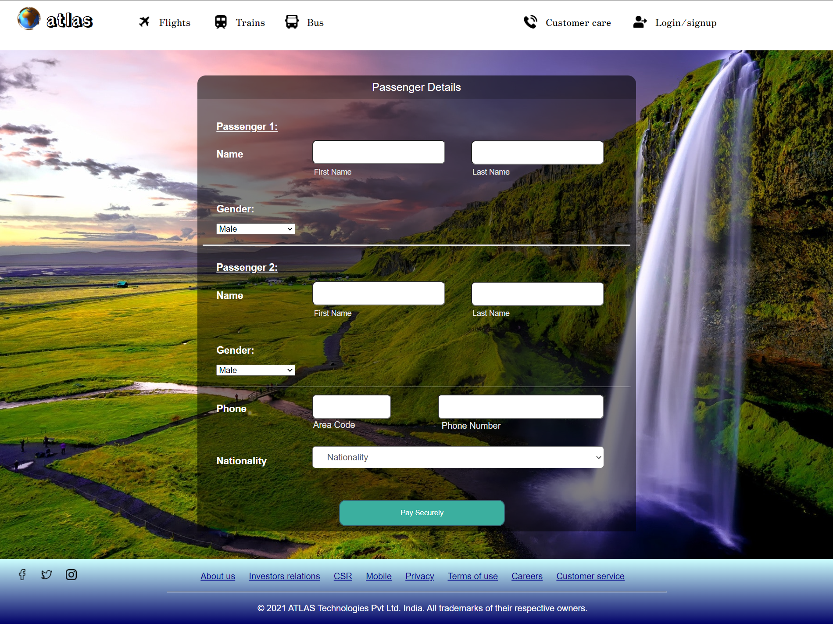

**Java Script for form validation in above pic:**

<script>

function FORM_VALIDATION() {

var firstname =

document.forms["RegForm"]["first_name"];

var lastname =

document.forms["RegForm"]["last_name"];

var phone =

document.forms["RegForm"]["phone"];

if (name.value == "") {

window.alert("Please enter your name.");

name.focus();

return false;

}

if (phone.value == "") {

window.alert(

"Please enter your telephone number.");

phone.focus();

return false;

}

if (phone.value.length < 10 || phone.value.length > 10) {

window.alert(

"Please enter a 10 digit phone number");

phone.focus();

return false;

}

return true;

}

</script>

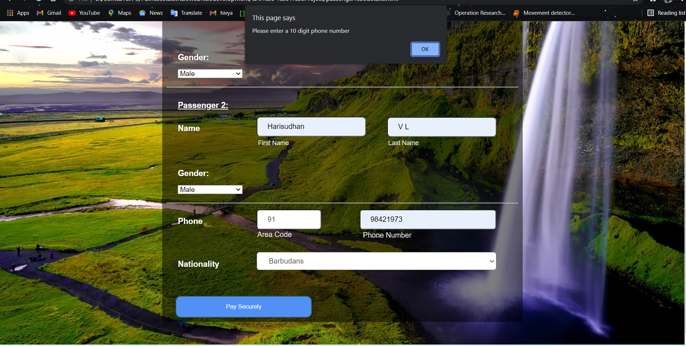

**Validation done through regular expression pattern, for verification refer the above code which are highlighted.**

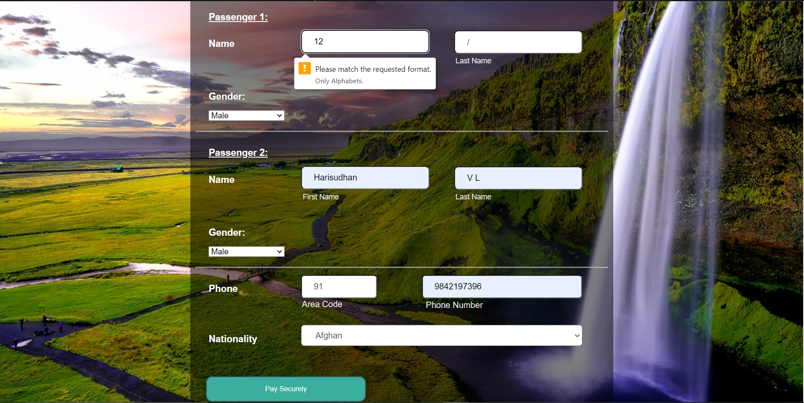

1. **Payment page:**

**HTML:**

<!DOCTYPE html>

<html lang="en">

<head>

<meta charset="UTF-8">

<meta name="viewport" content="width=device-width, initial-scale=1.0">

<title>Payment</title>

<link href="paymentform.css" rel="stylesheet">

<link href="https://stackpath.bootstrapcdn.com/font-awesome/4.7.0/css/font-awesome.min.css" rel="stylesheet"

integrity="sha384-wvfXpqpZZVQGK6TAh5PVlGOfQNHSoD2xbE+QkPxCAFlNEevoEH3Sl0sibVcOQVnN" crossorigin="anonymous">

<link rel="stylesheet" type="text/css" href="c.css">

<link href="https://fonts.googleapis.com/css2?family=Rampart+One&display=swap" rel="stylesheet">

<link href="https://fonts.googleapis.com/css2?family=Zen+Antique&display=swap" rel="stylesheet">

<link href="https://fonts.googleapis.com/css2?family=Oswald:wght@600&display=swap" rel="stylesheet">

<!-- Navigation bar-->

<header>

<div class="header" style="background-color: white; padding-top: 10px;">

<img style="height:45px ;margin-left: 30px" src="globe.png" alt = "logo">

<h1 style="margin-top: 0px; padding-bottom: 10px">atlas</h1>

<img style="height: 25px; margin-left: 250px; margin-top: -40px;" src="plane.png">

<a class="four" href="Home_page.html" style="margin-left: 290px; margin-top: -40px;" >Flights</a>

<img style="height: 25px; margin-left: 390px; margin-top: -40px;"src="train.png">

<a class="four" href="train.html" style="margin-left: 430px; margin-top: -40px;" >Trains</a>

<img style="height: 25px; margin-left: 520px; margin-top: -40px;"src="bus.png">

<a class="four" href="bus.html" style="margin-left: 560px; margin-top: -40px;" >Bus</a>

<img style="height: 25px; margin-left: 1155px; margin-top: -40px;"src="user.png">

<a class="four" href="login_signup.html" style="margin-left: 1195px; margin-top: -40px;" >Login/signup</a>

<img style="height: 25px; margin-left: 955px; margin-top: -40px;"src="telephone-call.png">

<a class="four" href="customer_care.html" style="margin-left: 995px; margin-top: -40px;" >Customer care</a>

</div>

</header>

<hr>

<style type="text/css">

*{

margin: 0;

padding: 0;

box-sizing: border-box;

}

body{

background-color: #f5f5f5;

background-image: url('payment_background.jpg');

font-family: Arial, Helvetica, sans-serif;

}

.wrapper{

background-color: #fff;

width: 500px;

padding: 25px;

margin: 25px auto 0;

box-shadow: 0px 0px 20px rgba(0,0,0,0.5);

}

.wrapper h2{

background-color: #fcfcfc;

color: #7ed321;

font-size: 24px;

padding: 10px;

margin-bottom: 20px;

text-align: center;

border: 1px dotted #333;

}

h4{

padding-bottom: 5px;

color: #7ed321;

}

.input-group{

margin-bottom: 8px;

width: 100%;

position: relative;

display: flex;

flex-direction: row;

padding: 5px 0;

}

.input-box{

width: 100%;

margin-right: 12px;

position: relative;

}

.input-box:last-child{

margin-right: 0;

}

.name{

padding: 14px 10px 14px 50px;

width: 100%;

background-color: #fcfcfc;

border: 1px solid #00000033;

outline: none;

letter-spacing: 1px;

transition: 0.3s;

border-radius: 3px;

color: #333;

}

.name:focus, .dob:focus{

-webkit-box-shadow:0 0 2px 1px #7ed32180;

-moz-box-shadow:0 0 2px 1px #7ed32180;

box-shadow: 0 0 2px 1px #7ed32180;

border: 1px solid #7ed321;

}

.input-box .icon{

width: 48px;

display: flex;

justify-content: center;

align-items: center;

position: absolute;

top: 0px;

left: 0px;

bottom: 0px;

color: #333;

background-color: #f1f1f1;

border-radius: 2px 0 0 2px;

transition: 0.3s;

font-size: 20px;

pointer-events: none;

border: 1px solid #00000033;

border-right: none;

}

.name:focus + .icon{

background-color: #7ed321;

color: #fff;

border-right: 1px solid #7ed321;

border: none;

transition: 1s;

}

.dob{

width: 30%;

padding: 14px;

text-align: center;

background-color: #fcfcfc;

transition: 0.3s;

outline: none;

border: 1px solid #c0bfbf;

border-radius: 3px;

}

.radio{

display: none;

}

.input-box label{

width: 50%;

padding: 13px;

background-color: #fcfcfc;

display: inline-block;

float: left;

text-align: center;

border: 1px solid #c0bfbf;

}

.input-box label:first-of-type{

border-top-left-radius: 3px;

border-bottom-left-radius: 3px;

border-right: none;

}

.input-box label:last-of-type{

border-top-right-radius: 3px;

border-bottom-right-radius: 3px;

}

.radio:checked + label{

background-color: #7ed321;

color: #fff;

transition: 0.5s;

}

.input-box select{

display: inline-block;

width: 50%;

padding: 12px;

background-color: #fcfcfc;

float: left;

text-align: center;

font-size: 16px;

outline: none;

border: 1px solid #c0bfbf;

cursor: pointer;

transition: all 0.2s ease;

}

.input-box select:focus{

background-color: #7ed321;

color: #fff;

text-align: center;

}

button{

width: 100%;

background: transparent;

border: none;

background: #7ed321;

color: #fff;

padding: 15px;

border-radius: 4px;

font-size: 16px;

transition: all 0.35s ease;

}

button:hover{

cursor: pointer;

background: #5eb105;

}

</style>

</head>

<body>

<div class="wrapper" style="margin-top:50px; margin-bottom: 50px; margin-left: 105px">

<h2>

Payment Form</h2>

<form method="POST">

<h4>

Account</h4>

<div class="input-group">

<div class="input-box">

<input type="text" placeholder="Full Name" required class="name" **pattern="[a-zA-Z ]{1,15}", title="Only Alphabets."**>

<i class="fa fa-user icon"></i>

</div>

<div class="input-box">

<input type="text" placeholder="Nick Name" required class="name" **pattern="[a-zA-Z ]{1,15}", title="Only Alphabets."**>

<i class="fa fa-user icon"></i>

</div>

</div>

<div class="input-group">

<div class="input-box">

<input type="email" placeholder="Email Adress" required class="name" **pattern="[a-z0-9._%+-]+@[a-z0-9.-]+\.[a-z]{2,4}$" title="Enter a valid E-mail address."**>

<i class="fa fa-envelope icon"></i>

</div>

</div>

<div class="input-group">

<div class="input-box">

<h4>

Date of Birth</h4>

<input type="text" placeholder="DD" class="dob" required>

<input type="text" placeholder="MM" class="dob" required>

<input type="text" placeholder="YYYY" class="dob" required>

</div>

<div class="input-box">

<h4>

Gender</h4>

<input type="radio" id="b1" name="gendar" checked class="radio">

<label for="b1">Male</label>

<input type="radio" id="b2" name="gendar" class="radio">

<label for="b2">Female</label>

</div>

</div>

<div class="input-group">

<div class="input-box">

<h4>

Payment Details</h4>

<input type="radio" name="pay" id="bc1" checked class="radio">

<label for="bc1"><span><i class="fa fa-cc-visa"></i> Credit Card</span></label>

<input type="radio" name="pay" id="bc2" class="radio">

<label for="bc2"><span><i class="fa fa-cc-paypal"></i> Paypal</span></label>

</div>

</div>

<div class="input-group">

<div class="input-box">

<input type="tel" placeholder="Card Number" required class="name" **pattern="[0-9]{16}" title="Enter only 16 digit number."**>

<i class="fa fa-credit-card icon"></i>

</div>

</div>

<div class="input-group">

<div class="input-box">

<input type="tel" placeholder="Card CVC" required class="name" **pattern="[0-9]{3}" title="Enter only 3 digit number."**>

<i class="fa fa-user icon"></i>

</div>

<div class="input-box">

<select>

<option>01 jun</option>

<option>02 jun</option>

<option>03 jun</option>

</select>

<select>

<option>2020</option>

<option>2021</option>

<option>2022</option>

</select>

</div>

</div>

<div class="input-group">

<div class="input-box">

<button type="submit" onclick="window.location.href='ticket_confirmation.html'">PAY NOW</button>

</div>

</div>

</form>

</div>

<!-- Footer -->

<footer class="footer" style="margin-top: 2px;">

<br>

<div style="margin-bottom: -40px; margin-left: 30px;">

<img style="width: 20px;" src="facebook.png"> &emsp; <img style="width: 20px;" src="twitter.png"> &emsp; <img style="width: 20px;" src="instagram.png">

</div>

<div class="footer_ref" style="margin-top: 20px">

<p><a class="one" href="">About us</a> &emsp; <a class="one" href="">Investors relations</a> &emsp; <a class="one" href="">CSR</a> &emsp; <a class="one" href="">Mobile</a> &emsp; <a class="one" href="">Privacy</a> &emsp; <a class="one" href="">Terms of use</a> &emsp; <a class="one" href="">Careers</a> &emsp; <a class="one" href="">Customer service</a> <br><br> </p>

</div><br><br><br><center style="margin-bottom: 20px;" ><hr></center>

<p style="margin-left:470px; padding-bottom: 20px; color: white">&copy; 2021 ATLAS Technologies Pvt Ltd. India. All trademarks of their respective owners.</p>

</footer>

</body>

</html>

**Payment page:**

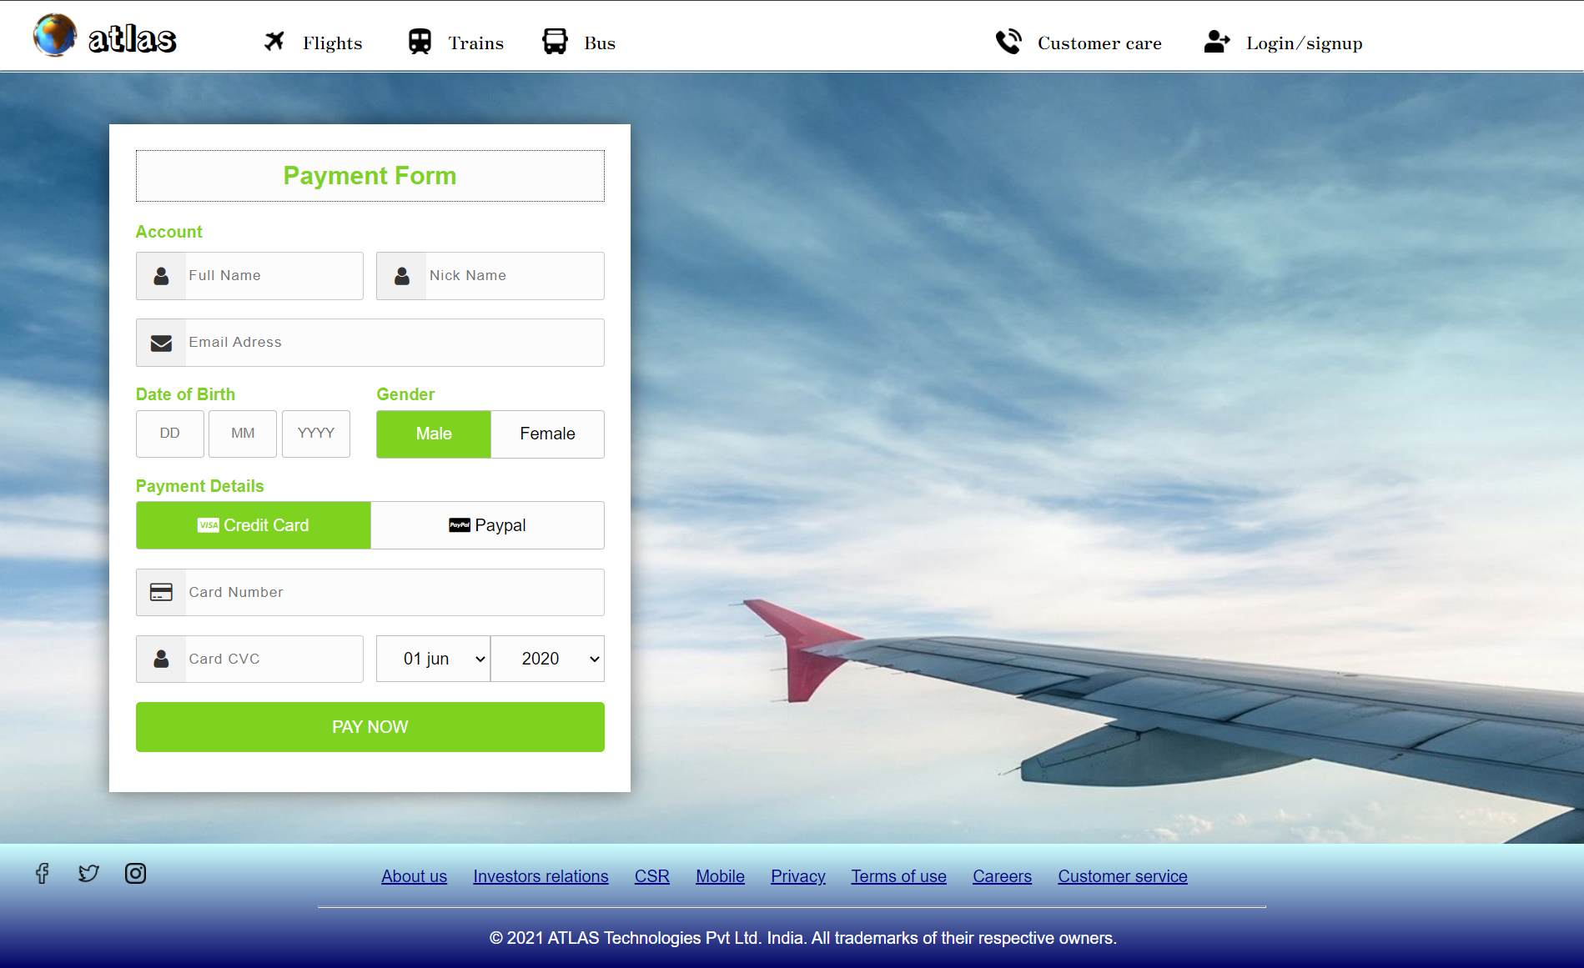

**Validation done through regular expression pattern, for verification refer the above code which are highlighted.**

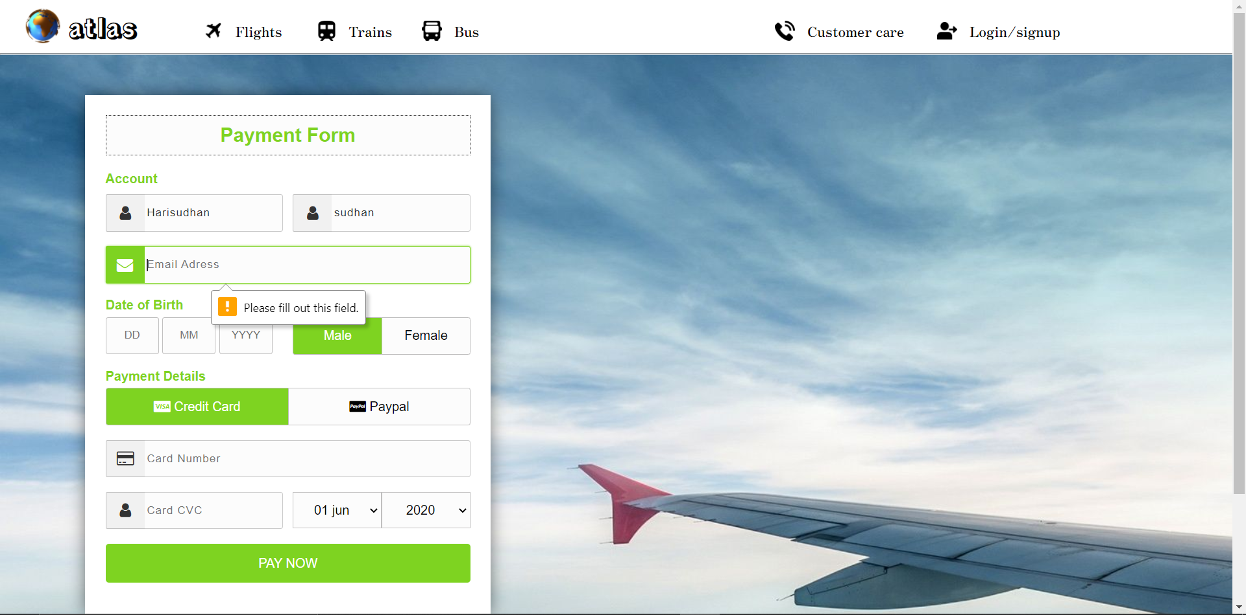

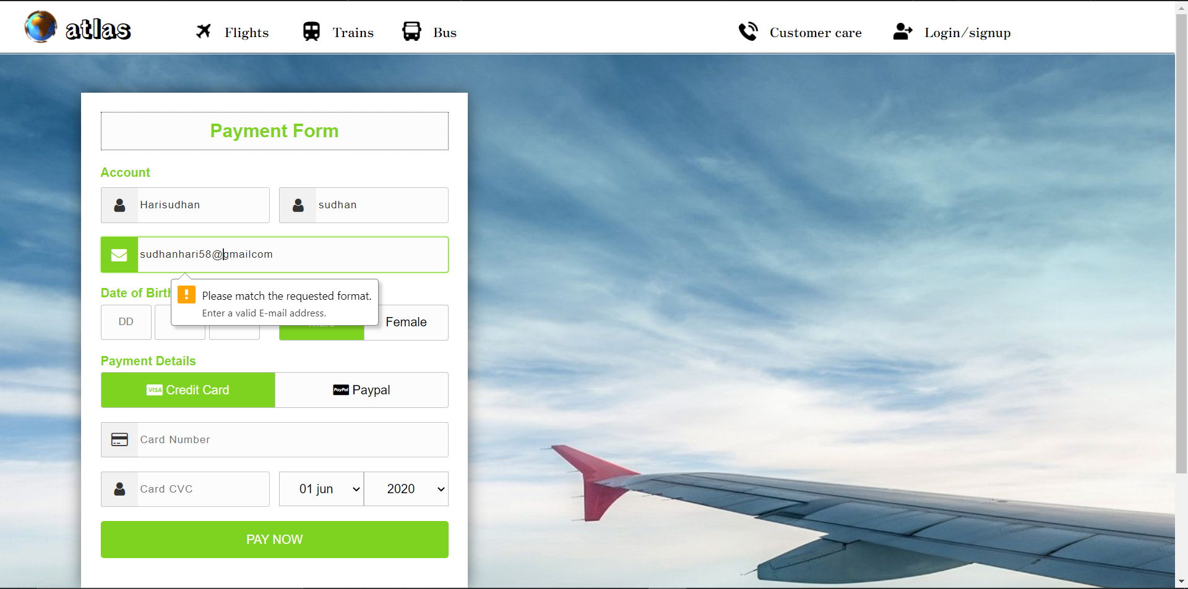

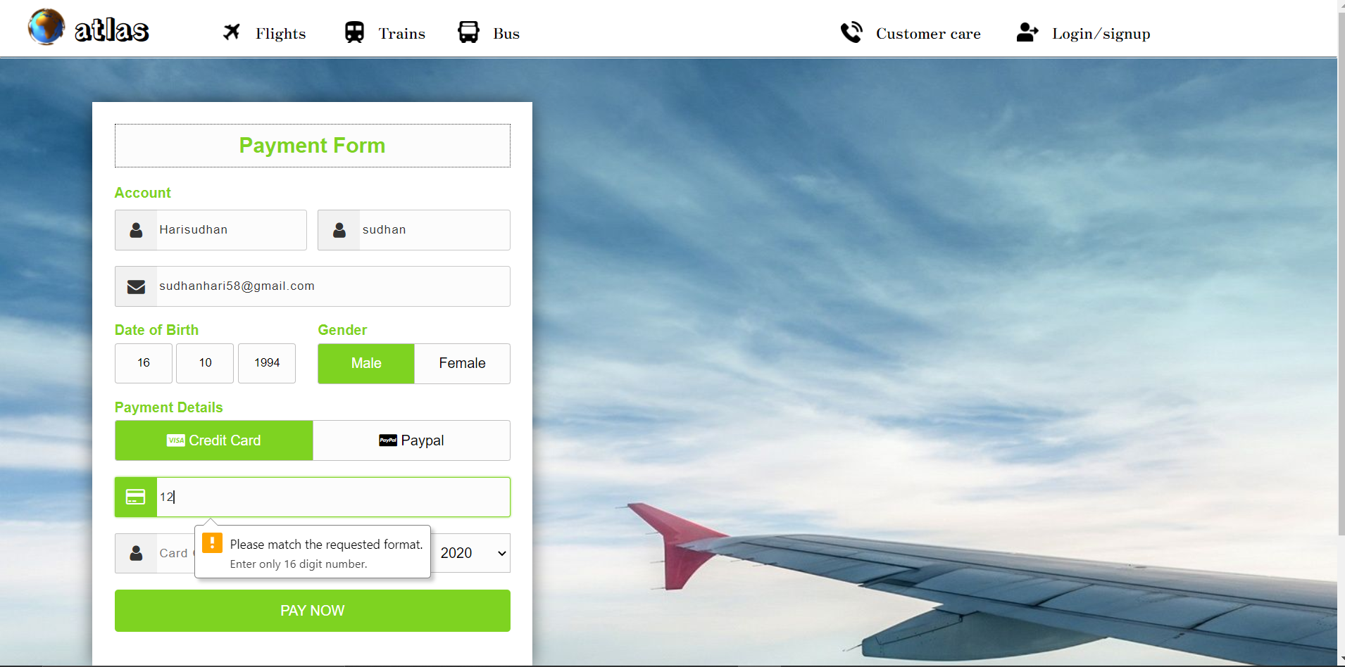

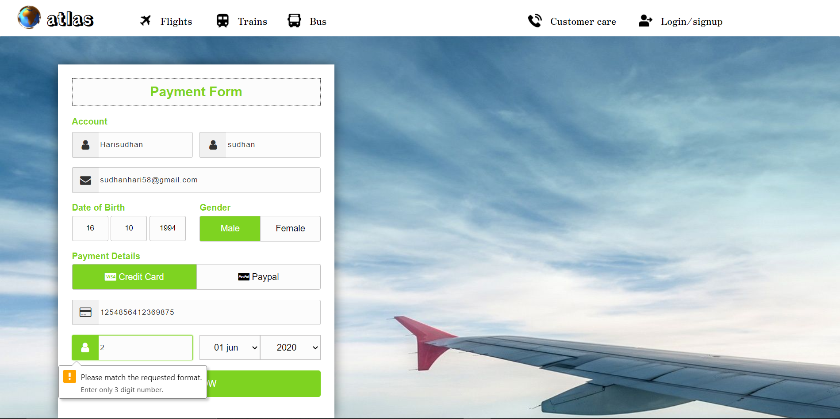

1. **Booking Confirmation page:**

**HTML:**

<!DOCTYPE html>

<html>

<head>

<meta charset="utf-8">

<title>Confirmation</title>

<link rel="stylesheet" type="text/css" href="style.css">

<link href="https://fonts.googleapis.com/css2?family=Rampart+One&display=swap" rel="stylesheet">

<link href="https://fonts.googleapis.com/css2?family=Zen+Antique&display=swap" rel="stylesheet">

<link href="https://fonts.googleapis.com/css2?family=Oswald:wght@600&display=swap" rel="stylesheet">

<script src="javascript_signup.js"></script>

<!-- Navigation bar-->

<header>

<div class="header">

<img style="height:45px ;" src="globe.png" alt = "logo">

<h1 style="margin-top: 5px;">atlas</h1>

<img style="height: 25px; margin-left: 300px; margin-top: -55px;" src="plane.png">

<a class="four" href="Home_page.html" style="margin-left: 340px; margin-top: -55px;" >Flights</a>

<img style="height: 25px; margin-left: 440px; margin-top: -55px;"src="train.png">

<a class="four" href="train.html" style="margin-left: 480px; margin-top: -55px;" >Trains</a>

<img style="height: 25px; margin-left: 570px; margin-top: -55px;"src="bus.png">

<a class="four" href="bus.html" style="margin-left: 610px; margin-top: -55px;" >Bus</a>

<img style="height: 25px; margin-left: 1305px; margin-top: -55px;"src="user.png">

<a class="four" href="login_signup.html" style="margin-left: 1345px; margin-top: -55px;" >Login/signup</a>

<img style="height: 25px; margin-left: 1105px; margin-top: -55px;"src="telephone-call.png">

<a class="four" href="customer_care.html" style="margin-left: 1145px; margin-top: -55px;" >Customer care</a>

</div>

</header>

<hr>

</head>

<body>

<center><h1 style="font-family: 'Zen Antique', serif;">Booking Confirmation</h1></center>

<div class="card">

<div class="container" style="padding-bottom: 20px;">

<img style="height: 110px;display: inline-block; float: left; margin-top: 30px;" src="plane.png" alt="Avatar" style="width:100%">&emsp;

<h4 style="margin-left: 150px;"><b>Dear XXX,</b></h4>

<p style="margin-left: 150px;font-size: 20px;">Congratulations! Your flight ticket booking is confirmed.</p>

<p style="margin-left: 150px;"><b>Reference number: DRF45V2K2FG23265</b></p>

</div>

</div><br><br>

<div class="card">

<div class="container" style="padding-bottom: 20px;">

<img style="height: 110px;display: inline-block; float: left; margin-top: 80px;" src="airport.png" alt="Avatar" style="width:100%">&emsp;

<h3 style="margin-left: 150px;"><b>Depart</b></h3>

<p style="margin-left: 150px;font-size: 20px;"><b>New Delhi &emsp;&emsp;&emsp;&emsp;&emsp;&emsp;&emsp;&emsp;&emsp;&emsp;&emsp;&emsp;&emsp;&emsp;&emsp;--->&emsp;&emsp;&emsp;&emsp;&emsp;&emsp;&emsp;&emsp;&emsp;&emsp; Abu Dhabi</b><br><br>Indhra Gandhi International Airport&emsp;&emsp;&emsp;&emsp;&emsp;&emsp;&emsp;&emsp;&emsp;&emsp;&emsp;&emsp;&emsp;&emsp;&emsp;&emsp;&emsp;Abu Dhabi International Airport <br><br> Departure time: FRI, 4/12/2021, 10:30 AM&emsp;&emsp;&emsp;&emsp;&emsp;&emsp;&emsp;&emsp;&emsp;&emsp;&emsp;&emsp;&emsp;&emsp; Arrival time:FRI, 4/12/2021, 02:30 PM<br><br> </p>

</div>

</div><br><br>

<div class="card">

<div class="container" style="padding-bottom: 20px;">

<img style="height: 110px;display: inline-block; float: left; margin-top: 30px;" src="passenger.png" alt="Avatar" style="width:100%">&emsp;

<h3 style="margin-left: 150px;"><b>Passenger details</b></h3>

<p style="margin-left: 150px;">Passenger Name: <b>XXXX</b> &emsp;&emsp;&emsp; Ticket number: <b>120364502</b> &emsp;&emsp;&emsp; Seat no: <b>A - 25</b> &emsp;&emsp;&emsp; Class: <b>BusinessClass</b></p><br>

<center><h1>HAPPY JOURNEY</h1></center>

</div>

</div><br><br>

<!-- Footer -->

<footer class="footer" style="margin-top: 0px;">

<br>

<div style="margin-bottom: -40px; margin-left: 30px;">

<img style="width: 20px;" src="facebook.png"> &emsp; <img style="width: 20px;" src="twitter.png"> &emsp; <img style="width: 20px;" src="instagram.png">

</div>

<div class="footer_ref">

<p><a class="one" href="">About us</a> &emsp; <a class="one" href="">Investors relations</a> &emsp; <a class="one" href="">CSR</a> &emsp; <a class="one" href="">Mobile</a> &emsp; <a class="one" href="">Privacy</a> &emsp; <a class="one" href="">Terms of use</a> &emsp; <a class="one" href="">Careers</a> &emsp; <a class="one" href="">Customer service</a> <br><br> </p>

</div><br><br><br><hr>

<p style="margin-left:470px; padding-bottom: 20px; color: white">&copy; 2021 ATLAS Technologies Pvt Ltd. India. All trademarks of their respective owners.</p>

</footer>

</body>

</html>

**Ticket Confirmation page:**

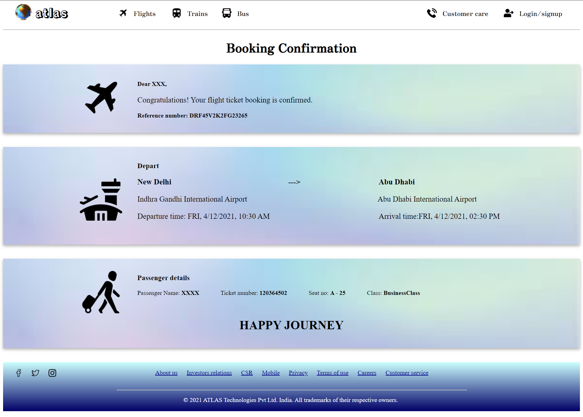

**NAVIGATION for booking a flight ticket:**

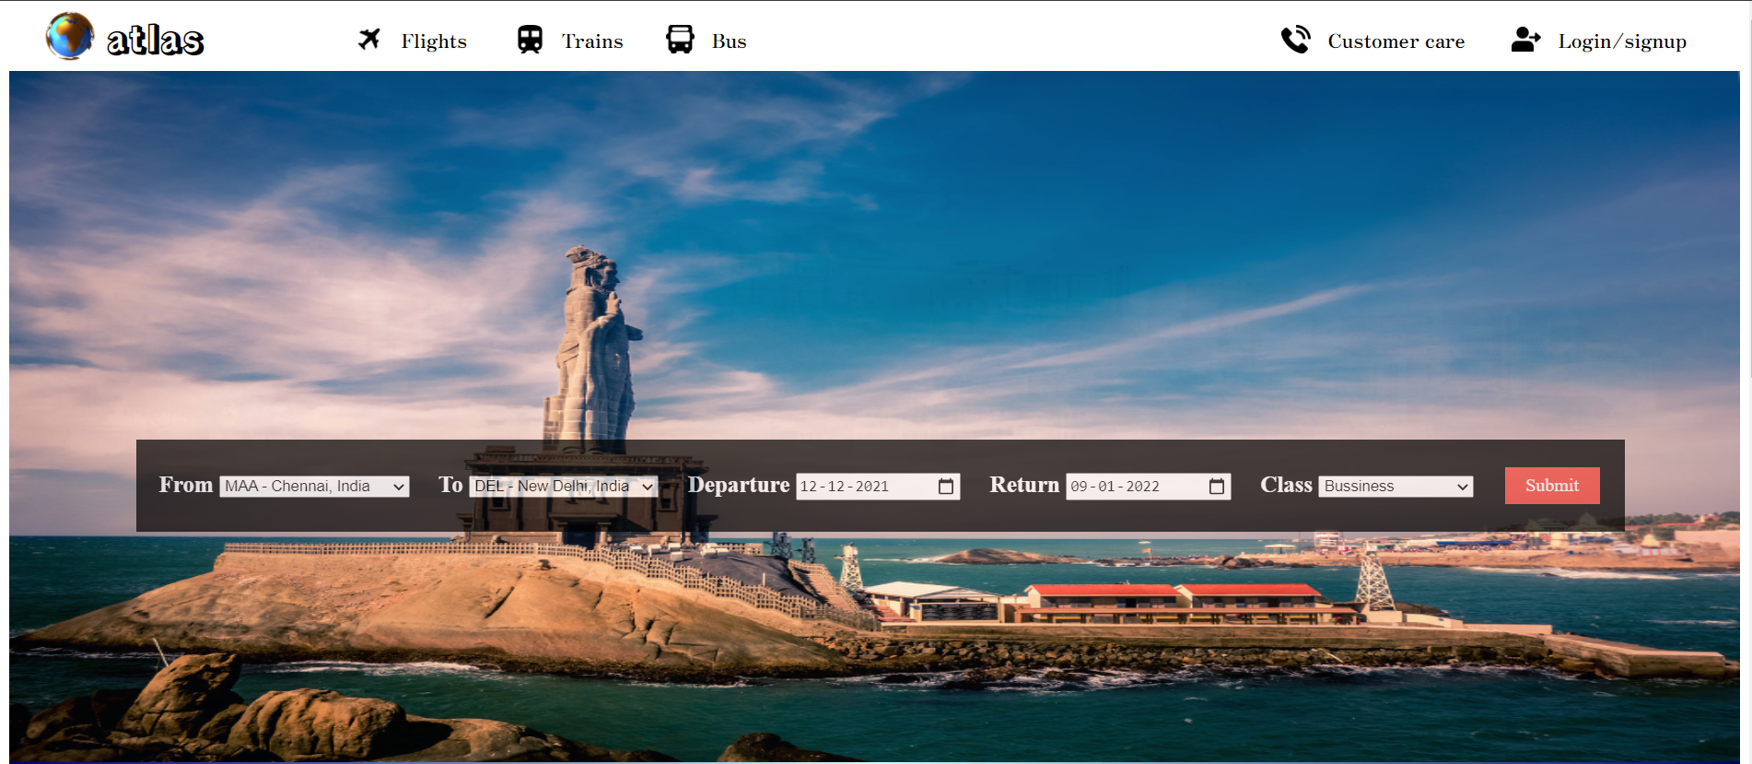

First click the Login.sign up page.

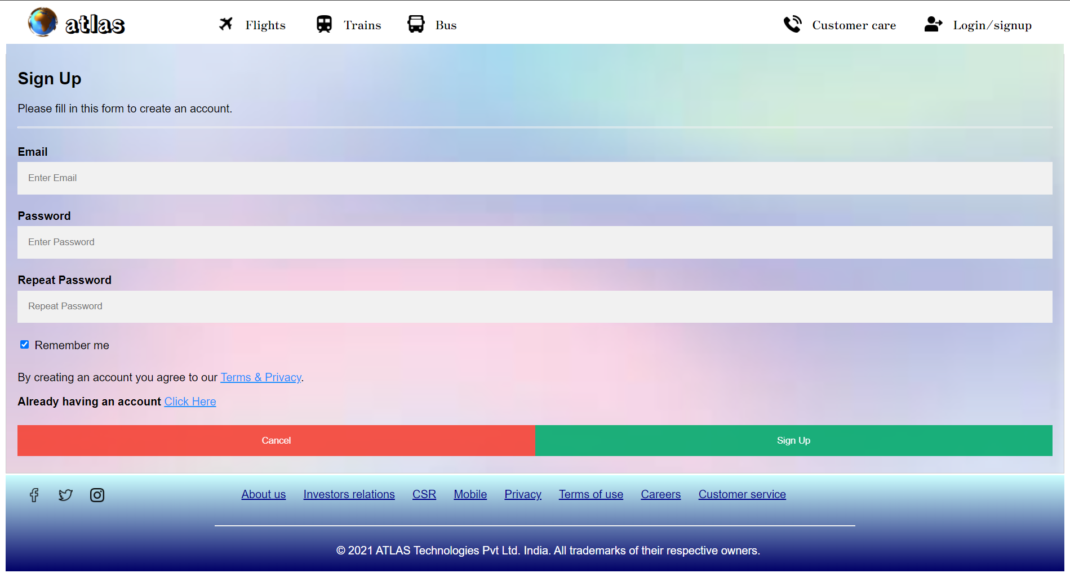

Create an account if not click already having an account as mentioned by black arraow.

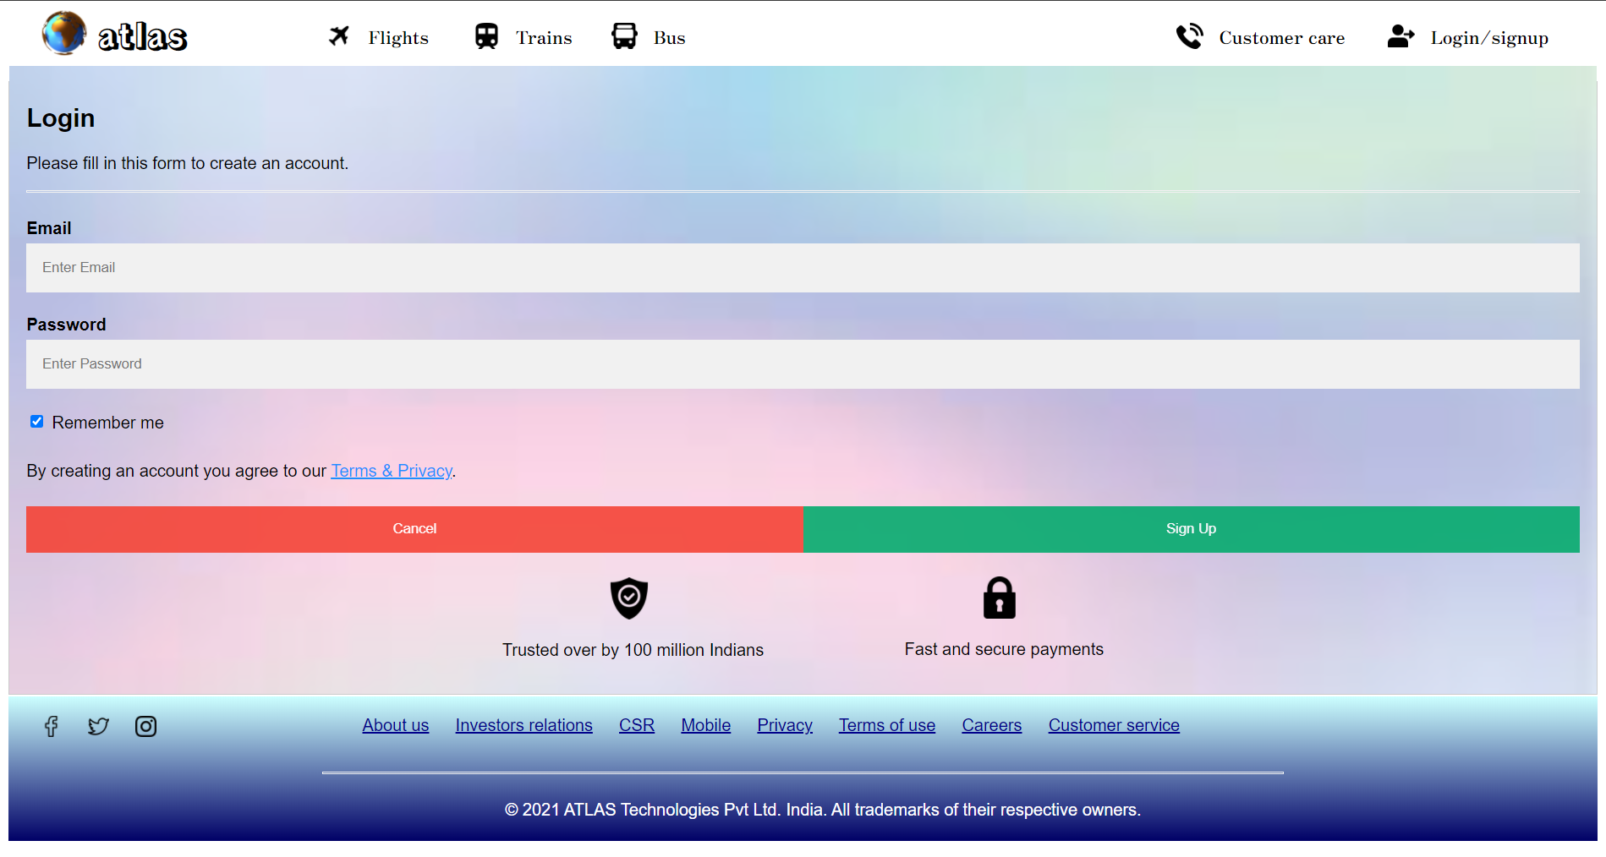

Enter the details and click sign up.



Enter the from and to.

Click the submit button mentioned by a white arrow to reach the flight selection page.

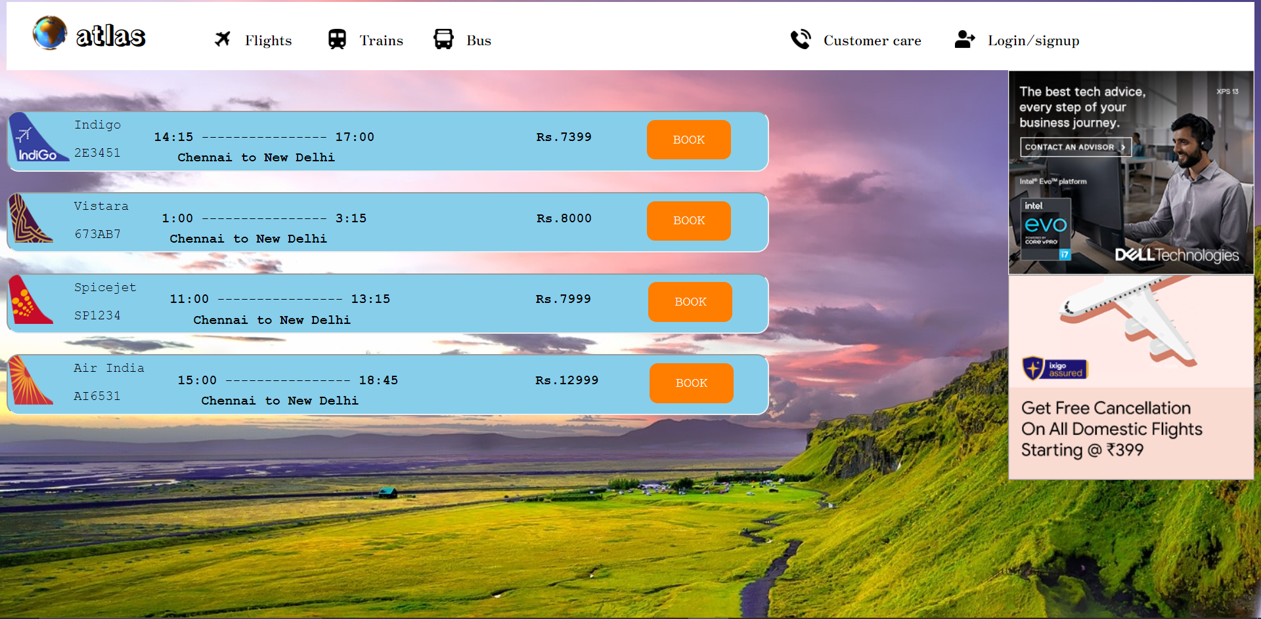

These are the available flights to Delhi from Chennai, click book button mention by white arrow to enter the passenger details.

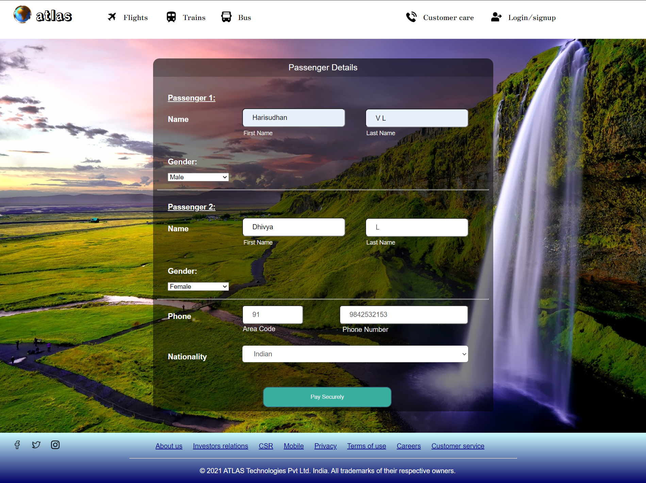

Enter the details and click pay securely as mention by white arrow to reach payment page.

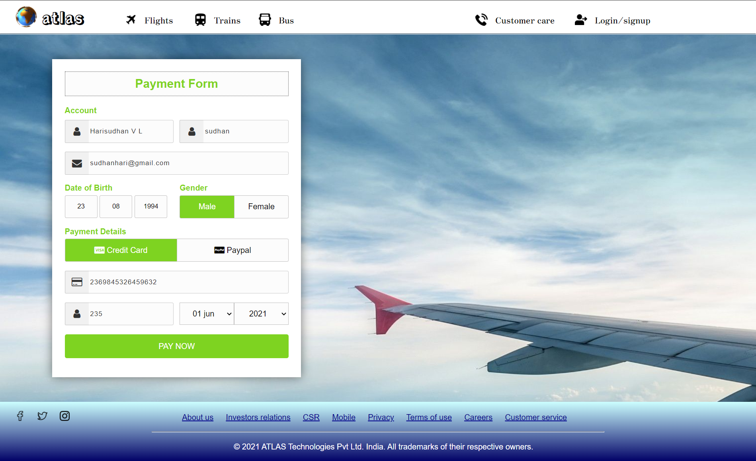

Enter the payment details and click pay now.

Ticket booking confirmation page arrives.

